*A project report on*

**HOME AUTOMATION USING HAND GESTURES**

*Submitted in partial fulfillment for the award of the degree of*

# Bachelor of Technology in Computer Science and

**Engineering with Specialization in Artificial Intelligence and Machine Learning**

*by*

**PHAROS SOPHY SAMUEL T J(20BAI1049)**



**SCHOOL OF COMPUTER SCIENCE AND ENGINEERING**

April,2024



### DECLARATION

I hereby declare that the thesis entitled “**HOME AUTOMATION USING HAND GESTURES**” submitted by me, for the award of the degree of Bachelor of Technology in Computer Science and Engineering with Specialization in Artificial Intelligence and Machine Learning, Vellore Institute of Technology, Chennai is a record of bonafide work carried out by me under the supervision of Bhavadharini R M.

I further declare that the work reported in this thesis has not been submitted and will not be submitted, either in part or in full, for the award of any other degree or diploma in this institute or any other institute or university.

**Place: Chennai**

**Date: November, 2024** **Signature of the Candidate**



**School of Computer Science and Engineering**

## CERTIFICATE

This is to certify that the report entitled **“HOME AUTOMATION USING GESTURES”** is prepared and submitted by **Pharos Sophy Samuel (20BAI1049)** to Vellore Institute of Technology, Chennai, in partial fulfilment of the requirement for the award of the degree of **Bachelor of Technology in Computer Science and Engineering with Specialization in Artificial Intelligence and Machine Learning** programme is a bonafide record carried out under my guidance. The project fulfils the requirements as per the regulations of this University and in my opinion meets the necessary standards for submission. The contents of this report have not been submitted and will not be submitted either in part or in full, for the award of any other degree or diploma and the same is certified.

Signature of the Guide:

Name: Bhavadharini R M

Date: November, 2024

Signature of the Internal Examiner Signature of the External Examiner

Name: Name:

Date: Date:

Approved by the Head of Department,

**B.Tech. CSE with Specialization in Artificial Intelligence and Machine Learning**

Name: Dr. Sweetlin Hemalatha C

Date:

(Seal of SCOPE)

### ABSTRACT

The incorporation of automation technologies has become essential for improving convenience and energy efficiency in the age of smart houses. This study offers a method of automating the home by using hand gestures as input commands. The CNN algorithm and an Arduino Uno board are used in the implementation to recognize hand gestures in real time. With the help of a motor driver to modify fan speed and an AC dimmer to modulate light intensity, the system manages a tiny fan and a lightbulb. Different features are activated by the hand motions that correspond to numbers one through five: Swing activates the fan at full speed, thumbs up lowers the fan speed, Fist brightens the lightbulb, Palm lowers the brightness of both lights, and Peace sign shuts off the system as a whole. The dataset used for training and calibration procedures is included in the thorough description of how the hardware and gesture recognition algorithm are integrated. The accuracy of the hand gesture detection system and the responsiveness of the automation features are demonstrated by the experimental findings. The conversation examines the project's contributions, discusses implementation issues, and offers possible directions for further home automation research. This study opens the door to user-friendly smart homes by offering a concrete and useful solution for simple home automation using simple hand gestures.

#### ACKNOWLEDGEMENT

It is my pleasure to express with deep sense of gratitude to Bhavadharini R M,

Associate Professor, School of Computer Science and Engineering, Vellore Institute of Technology, Chennai, for his constant guidance, continual encouragement, understanding; more than all, she taught me patience in my endeavor. My association with her is not confined to academics only, but it is a great opportunity on my part of work with an intellectual and expert in the field of Machine Learning.

It is with gratitude that I would like to extend my thanks to the visionary leader Dr. G. Viswanathan our Honorable Chancellor, Mr. Sankar Viswanathan, Dr. Sekar Viswanathan, Dr. G V Selvam Vice Presidents, Dr. Sandhya Pentareddy, Executive Director, Ms. Kadhambari S. Viswanathan, Assistant Vice-President, Dr. V. S. Kanchana Bhaaskaran Vice-Chancellor, VIT Chennai and Dr. P. K. Manoharan, Additional Registrar for providing an exceptional working environment and inspiring all of us during the tenure of the course.

Special mention to Dr. Ganesan R, Dean, Dr. Parvathi R, Associate Dean Academics, Dr. Geetha S, Associate Dean Research, School of Computer Science and Engineering, Vellore Institute of Technology, Chennai for spending their valuable time and efforts in sharing their knowledge and for helping us in every aspect.

In jubilant state, I express ingeniously my whole-hearted thanks to Dr. Sweetlin Hemalatha C, Head of the Department, B.Tech. CSE with Specialization in Artificial Intelligence and Machine Learning and the Project Coordinators for their valuable support and encouragement to take up and complete the thesis.

My sincere thanks to all the faculties and staffs at Vellore Institute of Technology, Chennai who helped me acquire the requisite knowledge. I would like to thank my parents for their support. It is indeed a pleasure to thank my friends who encouraged me to take up and complete this task.

Place: Chennai

Date: April, 2024 **Pharos Sophy Samuel T J(20BAI1049)**

### CONTENTS

**CONTENTS ………………………………………………………………**6

**LIST OF FIGURES ……………………………………………………...** 8

**LIST OF TABLES ……………………………………………………….** 8

**CHAPTER 1**

**INTRODUCTION**

1.1 INTRODUCTION …………………………………………………………………11

1.2 PROJECT STATEMENT ………………………………………………………….12

1.3 BACKGROUND/SIGNIFICANCE OF STUDY ………………………………… 15

1.4 OBJECTIVES …………………………………………………………………….. 17

1.5 CHALLENGES ……………………………………………………………………18

**CHAPTER 2**

**PROPOSED SYSTEM**

2.1 PROPOSED SYSTEM ……………………………………………………………...19

2.2 PROPOSED SYSTEM EFFICIENCY ……………………………………………...27

2.3 LIST OF MODULES …………………………………………………………….....28

2.4 EXPLANATION ……………………………………………………………………29

**CHAPTER 3**

**IMPLEMENTATION**

3.1 CODE AND EXPLANATION …………………………………………………… 31

3.2 RESULTS …………………………………………………………………………. 49

**CHAPTER 4**

**CONCLUSION AND FUTURE WORK**

4.1 CONCLUSION …………………………………………………………………… 57

4.2 FUTURE WORK …………………………………………………………………. 57

**REFERENCES**

4.3 REFERENCES ……………………………………………………………………..60

**APPENDICES**

4.4 APPENDICES ………………………………………………………………………61

**LIST OF FIGURES**

* 1. SYSTEM CONFIGURATION DIAGRAM 21
  2. CAPTURE.PY 31
  3. TRAINING.PY 32
  4. TESTING.PY 34
  5. VISUALIZE.PY 36
  6. PREDICT.PY 40
  7. GENERATOR.PY 42
  8. HOME_AUTOMATION.INO 46
  9. HARDWARE SETUP 51
  10. GESTURE RECOGNITION FOR SWING 52
  11. GESTURE RECOGNITION FOR THUMBS UP 53
  12. GESTURE RECOGNITION FOR FIST 54
  13. GESTURE RECOGNITION FOR PALM 55
  14. GESTURE RECOGNITION FOR PEACE SIGN 56

**LIST OF TABLES**

1. LITERATURE SURVEY 16

2. SYSTEM EFFICIENCY COMPARED IN A TABULAR FORMAT 27

**Chapter 1**

### Introduction

* 1. INTRODUCTION

The way smart technologies are incorporated into homes has changed significantly in recent years, giving homeowners more convenience, comfort, and energy efficiency. Gesture-based control systems have attracted a lot of attention among the different home automation strategies because they have the ability to provide a hands-free and intuitive interaction paradigm. By providing a thorough implementation of hand gesture-based home automation using the Arduino Uno board and the CNN algorithm for gesture recognition, this research aims to advance this developing field. The majority of current home automation models rely on conventional control interfaces like voice commands, manual switches, and mobile applications. Even though these techniques have worked well, they might not provide the smooth and organic engagement that gesture-based systems provide. By doing away with physical interfaces and enabling users to easily operate devices with hand gestures, gesture-based systems have the potential to improve user experience.

Nevertheless, there are certain disadvantages to the current hand gesture-based home automation models. The intricacy and expense of the hardware needed for accurate gesture recognition is one frequent drawback. Specialized sensors and depth-sensing cameras, which are frequently used in these systems, can be costly, limiting the accessibility of these technologies to a larger audience.

Furthermore, there are serious issues with gesture recognition's accuracy and dependability across a range of distances and lighting conditions, which can result in accidental activations or system faults. The absence of defined methods and gesture sets among various systems is another significant disadvantage. Inconsistencies in gesture recognition algorithms might restrict the interoperability of devices from different manufacturers and cause a high learning curve for consumers. Additionally, these systems' capacity to accommodate a wide range of user preferences and introduce new features is frequently limited, which prevents gesture-based home automation from reaching its full potential. For hand gesture-based systems to be widely adopted and integrated into regular smart homes, these constraints must be addressed.

By putting out a comprehensive approach that not only gets around these problems but also improves the user experience overall, our research aims to help improve on current models. The goal is to develop a gesture-based home automation system that is not only precise and dependable but also reasonably priced and available to a wider range of customers by combining cutting-edge algorithms and hardware elements. In order to address these issues, this study aims to provide a solution that not only lessens the shortcomings of the current models of gesture-based home automation but also provides a cost-effective, effective, and adaptable substitute. This project intends to build a reliable and flexible gesture detection system together with hardware components that can operate different devices within a smart home setting by integrating the CNN algorithm with the Arduino Uno board. The goal of this research is to advance home automation by resolving the shortcomings of existing models, hence increasing its usability and accessibility for a wide variety of homes.

Furthermore, in order to guarantee a uniform and intuitive experience across many platforms, the suggested solution recognizes the significance of standardization in gesture recognition models. The goal of the project is to improve the interoperability of devices from various manufacturers and reduce the learning curve for consumers by creating a common set of gestures and interaction protocols. Furthermore, the system's hardware components' low cost and ease of use help democratize the advantages of gesture-based home automation by making the technology available to a larger audience.

The project offers a unique method of home automation that makes use of the natural ability of hand movements to overcome these obstacles. Our project intends to develop a smooth and user-friendly method for consumers to operate their home appliances and gadgets by utilizing gesture detection technology and fusing it with intelligent hardware elements. With our technology, users can now turn on the lights, change the fan speed, and accomplish other simple operations by simply waving their hand. Gone are the days of fumbling with remote controllers or navigating through complex interfaces.

Our project's key component is the creative application of CNN and other deep learning algorithms to precisely identify and categorize hand movements in real time. Our technology effortlessly integrates gesture-based control into the smart home ecosystem by converting recognized gestures into actionable commands when paired with an Arduino Uno microcontroller and a range of hardware components, including relays, motor drivers, and dimmers. Additionally, this study aims to tackle the problem of customisation and adaptability in current systems. In order to accommodate a wide range of user preferences and enable the smooth integration of new features, the suggested system incorporates a flexible and modular design. By allowing the gesture-based home automation system to adapt to changing user needs and technical improvements, this flexibility not only improves the user experience but also future-proofs the technology.

In this work, we present a thorough description of our hand gesture-based home automation system, including its implementation, methodology, and functionality. We also go over the possible uses, advantages, and future prospects of gesture-based home automation, emphasizing how it will revolutionize how we engage with our houses. An important advancement in the field of gesture-based home automation is represented by this study. Through a combination of sophisticated algorithms, reasonably priced hardware components, standardization, and adaptability, the suggested solution seeks to address the shortcomings of current models and open the door to a more inclusive and user-friendly smart home experience. The development of gesture-based home automation is evidence of the continuous search for smooth, effective, and easily accessible solutions for contemporary homes, as smart technology continue to penetrate our daily lives.

* + 1. ADVANTAGES

Compared to conventional control methods, the hand gesture-based home automation system has the following benefits, which improve user experience, accessibility, and convenience:

* Easy Control:
  + Hand gestures offer a smooth and easy way to communicate, enabling users to operate household appliances with basic hand motions. The functioning of several appliances is streamlined by this user-friendly interface, which does away with the need for physical switches or remote controls.
* Accessibility:
  + People with disabilities or mobility limitations can utilize the automation system thanks to the use of hand gestures. Hand gesture control guarantees that everyone can effortlessly use and manage household equipment by doing away with the need for manual dexterity or fine motor abilities.
* Hands-Free Operation:
  + By eliminating the need to grasp remote controls or touch buttons, hand gesture-based control allows users to operate household appliances hands-free. When communicating with gadgets from a distance or when users have their hands busy, this hands-free functionality is especially helpful.
* Improved User Experience:
  + The entire user experience is improved by the smooth incorporation of hand gestures into the home automation system. It increases customer happiness and pleasure of automated chores by providing a fresh and entertaining method of interacting with smart home appliances.
* Adaptability:
  + To accommodate various user preferences and environments, hand gesture recognition algorithms can be taught and modified to identify a wide range of gestures and commands. This Flexibility guarantees that the automation system will continue to function well and respond in a variety of environments.
* Versatility:
  + A variety of home appliances such as lighting, fans, thermostats and entertainment systems, maybe be controlled using hand gestures. Because of its adaptability, users can tailor their automation configuration to suit their requirements and tastes.

#### PROJECT STATEMENT

By creating an advanced home automation system that uses hand gestures as its main control method, the project seeks to completely transform how people interact with their living spaces. Utilizing the advanced CNN gesture detection algorithm and the Arduino Uno microcontroller, the system provides a smooth and user-friendly interface for managing a variety of home appliances and gadgets. People can easily control the functioning of appliances, fans, lights, and other equipment with basic hand movements thanks to an intuitive setup. This method offers a more flexible and user-friendly way to handle home automation duties by doing away with the requirement for conventional physical switches or remote controllers.

Improving home automation's inclusion and accessibility is one of the project's main goals. The system accommodates people with disabilities or mobility limitations by offering a hands-free control option, enabling them to easily and freely manage their home environment. Additionally, by combining sophisticated gesture recognition algorithms with reasonably priced hardware, the project seeks to maximize the system's dependability and performance. The CNN algorithm provides reliable and accurate gesture detection capabilities, and the Arduino Uno microcontroller guarantees cost and accessibility. The project's overall goal is to advance home automation technologies and create more inclusive, adaptable, and user-centric smart homes.

1.3 BACKGROUND/SIGNIFICANCE OF STUDY

This study's backdrop is the rising demand for and interest in smart home technologies that provide efficiency, convenience, and improved quality of life. Conventional interfaces like voice commands, mobile applications, and remote controllers have been the foundation of traditional home automation systems. While these methods are successful, they can occasionally be difficult for some users to utilize, especially those with disabilities or mobility restrictions. Given these drawbacks, it is evident that more user-friendly and intuitive control systems that can accommodate a wide variety of users are required. Using the expressive and organic motions of the human hand to communicate with smart home appliances, hand gesture-based control systems have become a viable option.

The literature survey is a thorough investigation and evaluation of previous studies, academic papers, and pertinent publications in a particular field of study. In addition to educating the reader about the present state of knowledge, the literature survey prepares the reader for the novelty and significance of the upcoming research by reviewing and synthesizing earlier studies. The survey places the suggested research into the larger scholarly discourse, detects trends, and provides insights into the development of ideas through a critical evaluation of the literature.

An enhanced and user-friendly approach to regulating home appliances is presented in this research. By using hand gestures in place of physical switches, the suggested approach improves home automation's usability and accessibility. An effective way to improve user experience and streamline device management in the home is to employ the APDS9960 gesture sensor and Arduino technology [1].

The paper suggests a real-time hand motion detection system that combines an Arduino UNO microcontroller, an Android app, and Support Vector Machines (SVM) and Convolution Neural Networks (CNN). In contrast to more conventional techniques like HOG, LBP, and SURF, the PC program uses Resnet50 for feature extraction while processing photos from the application [2].

IoT technology, such as speech and hand motion control, is highlighted in the report as an inclusive option for those with mobility restrictions. An interconnected network of entities made possible by connectivity, software, sensors, actuators, and device interconnectivity is known as the Internet of Things. Data collection is made possible by this connectivity, which serves as the foundation for the suggested technology. The study makes a contribution by using IoT to develop a machine control system that is both flexible and reasonably priced for people with impairments, with a focus on speech and hand motion control for inclusion [3].

For simple appliance control, the suggested Home Automation model uses an Android app as an intuitive remote control that recognizes gestures using the smartphone's camera. Adding the Raspberry Pi improves portability and versatility. This method eliminates manual intervention by automating tasks using inexpensive smart sensors managed by a Raspberry Pi, thereby addressing labour-intensive components of smart home systems. In terms of smart home automation, the Android app is highlighted for its accessibility, scalability, security, and ease of use [4].

This study examines hand gesture detection applications in computer vision with an emphasis on how they affect electrical equipment operation. It lists the essential elements of a vision-based system for recognizing sign language, with a focus on pre-processing, feature extraction, and classification. The study emphasizes the necessity of a technique that guarantees precise sign language identification in a range of settings. The goal of the research is to bridge the gap between textual representation and gestural communication by effortlessly translating sign language into text. The direct interface between gesture-based automation and the control model is demonstrated by the ability of the resultant control model to handle domestic appliances [5].

This research proposes a real-time on-device Hand Gesture Recognition system for XR applications. It works with a variety of gadgets, including more affordable laptops and cell phones as well as more expensive Smart Glasses. With one or two hands, it can control both static and dynamic motions while accounting for egocentric viewpoint. The method breaks down the gesture detection problem into two smaller tasks: initial identification of the human hand skeleton from a single RGB camera using Media Lab Hands, followed by movement recognition using the hand skeleton. The technique uses popular datasets such as Ego Gesture and Jester. To increase the number of datasets that are available, they offer a method for generating large artificial video datasets for hand movements. In order to increase the number of datasets currently available, they offer a method for building large fake video datasets for hand gestures, together with behavioural trees that may be utilized to produce variations of the learnt gestures [6].

For better hand gesture detection, this paper proposes a novel hybrid approach that combines Transformers and 3D Convolutional Neural Networks (CNNs). By computing high-level semantic skeleton embeddings using a 3D-CNN to capture local spatial and temporal characteristics of hand gestures, the method gets over existing restrictions. Long-range temporal dependencies in the skeleton sequence are effectively captured by incorporating a transformer network with a self-attention mechanism [7].

The study emphasizes how crucial gestures are to human communication and how useful they are in a variety of contexts. It acknowledges the smooth human-computer interface of real-time gesture recognition systems and focuses in particular on their increasing popularity. By developing reasonably priced vision-based input software specifically designed for gesture-controlled media player operation, the project under discussion adds value. The technology contributes to the advancement of affordable and accessible gesture-based control systems by integrating computer vision and gesture recognition algorithms [8].

Without strong benchmarks or established criteria to evaluate their effectiveness, each paper presents new approaches and technology for home automation and hand gesture identification. As such, it becomes difficult for scholars and practitioners to determine the relative effectiveness and scalability of these various methods. It is difficult to assess the generalizability and applicability of the suggested methods in larger contexts of gesture recognition and smart home systems due to the lack of common datasets and uniform evaluation standards.

This work is important because it aims to create a home automation system that uses hand gestures as its main control method. The goal of the project is to develop a system that provides a smooth and user-friendly interface for operating household appliances and gadgets by combining hardware elements like the Arduino Uno microcontroller with cutting-edge gesture detection algorithms like CNN.

Table 1.1. Literature Survey

|  |  |  |  |  |
| --- | --- | --- | --- | --- |
| Article Title | Year Of Publish | Authors | Paper Summary | Limitations |
| [1] Finger Gesture Recognition based Home Automation using IOT | 2023 | Neha G , Harika CH, Swetha G , Vishnu Kanth G | The system combines an APDS9960 sensor and an Arduino UNO board to recognise hand gestures. The board receives a signal from this sensor and uses it to operate the gadgets. | The proposed method cannot track movements. |
| [2] Vision based Hand gesture pattern recognition enabled home automation system using Internet of Things | 2021 | R Jayanthi, A Bhuvaneswari, S Rajkumar, K P Rama Prabha | This paper presents a Support Vector Machine (SVM) and Convolution Neural Network (CNN) based hand gesture recognition system to automate various home devices. | This method applies applaud recognition but they have not incorporated it fully. |
| [3] IoT based enabling home automation system for individuals with diverse disabilities | 2023 | P. Anuradha,  K. Vasanth,  G. Renuka,  A. Rajeshwar Rao | Voice control is facilitated by leveraging an internet-based Speech – To - Text functionality within MIT App Inventor. | This method does not work with hand gestures. |
| [4] IOT based home applications controlling using vision and gesture through raspberry pi | 2023 | J L Sarwani Theeparthi ,  Sape Chittibabulu | The user's gesture input is captured using an Android application and sent to the Raspberry Pi , The system uses a convolutional neural network algorithm. | This system work with only 4 hand gestures. |
| [5] Gestures Controlled Home Automation using Deep Learning: A Review | 2021 | A. D. Harale , Amruta S. Bankar  And  K. J. Karande | This paper presents a Support Vector Machine (SVM) and Convolution Neural Network (CNN) based hand gesture recognition system to automate various home devices. | It work only for close proximity. |
| [6] Hand gesture recognition using recurrent neural networks and synthetic data generation | 2023 | F. Sabbarese ,  L. Magliulo,  P. Carratu ,  M. Romano | They propose a RNN. The architecture comprises two layers of either LSTM or GRU and a Fully Connected output layer. | When compared with online scenario,offline scenario doesn’t work good. |
| [7] Real - Time Monocular Skeleton-Based Hand Gesture Recognition Using 3D-Jointsformer | 2023 | Enmin Zhong,  Carlos R. del-Blanco,  Daniel Berjón , Fernando Jaureguizar  and  Narciso García | A hybrid approach that combines 3D Convolutional Neural Networks (3D-CNNs) and Transformers is proposed. | Requires high GPU. |
| [8] Computer Vision based Media Control using Hand Gestures | 2023 | Sangamesh Narayanpethkar, Abhishek Makude, Samrudh S,  Yashraj Khose,  A. D. Gujar. | This project implements computer vision and gesture recognition techniques and develops a software for controlling the media player. | It works only for pausing media. |
| [9] Convolutional neural networks framework for human hand gesture recognition | 2023 | Aseel Ghazi Mahmoud,  Ahmed Mudheher Hasan,  Nadia Moqble Hassan | Here CNN framework with multiple layers. proposed system provides excellent results of accuracy, precision,recall, and F1-score. | Doesn’t work for dynamic gesture. |
| [10] Improving Real-Time Hand Gesture Recognition with Semantic Segmentation | 2021 | Gibran Benitez-Garcia ,  Lidia Prudente-Tixteco ,  Luis Carlos Castro-Madrid ,  Rocio Toscano-Medina | Here, they employ a light-weight semantic segmentation method (FASSD-Net). | Requires high computational cost. |

1.4 Objective

* Create a Gesture Recognition Algorithm:
  + The main goal of the research is to create a reliable gesture recognition algorithm that can recognize and understand hand motions in real time. This entails using sophisticated machine learning methods, such the CNN algorithm, to teach the system to identify particular hand gestures that go along with different commands.
* Combine Hardware Elements:
  + Integrating hardware elements, such as an Arduino Uno microcontroller, sensors, actuators, and other required peripherals, to produce a workable home automation system is another important goal. This entails creating and putting together the hardware configuration that will allow the controlled devices and the gesture detection algorithm to communicate.
* Apply Gesture-Based Control:
  + The goal of the project is to apply gesture-based control features to a variety of home appliances and gadgets, including lighting, fans, and other smart devices. This entails assigning matching actions, such turning devices on or off, changing settings, or triggering particular functionalities, to recognized hand gestures.
* Enhance System Performance:
  + To guarantee responsiveness, precision, and dependability, one of the main goals is to enhance the gesture-based home automation system's performance. To improve user experience and system efficiency, this entails optimizing hardware configurations, reducing latency, and fine-tuning the gesture detection algorithm.
* Assess Usability and Accessibility:
  + The study aims to assess the produced system's usability and accessibility, especially with regard to accommodating people with disabilities or mobility limitations. To evaluate how well the system satisfies the demands of various user groups, user testing sessions and feedback collection are conducted.
* Record and Share Results:
  + Lastly, the study intends to record the gesture-based home automation system's design procedure, implementation specifics, and performance assessments. This include creating research papers, presentations, and technical documentation to share discoveries with academic and business audiences and add to the body of knowledge in the areas of home automation and human-computer interaction.

1.5 Challenges

To guarantee the efficacy and usefulness of a gesture-based home automation system, a number of obstacles must be overcome during implementation. Creating a reliable and effective gesture recognition algorithm that can consistently read a variety of hand movements in a range of environmental situations is a major task. The algorithm's performance can be hampered by variations in lighting, background clutter, and occlusions; hence, advanced pre-processing and feature extraction approaches are needed to improve recognition accuracy.

Furthermore, it might be difficult to maintain low latency while guaranteeing real-time responsiveness, particularly in contexts with limited resources like embedded devices. In order to facilitate seamless communication and interaction between the system and controlled devices, another difficulty is to seamlessly integrate the hardware components with the gesture recognition algorithm. To maximize system performance and dependability, compatibility problems, hardware constraints, and power consumption factors need to be properly addressed. Additionally, there is a usability difficulty in creating an intuitive user interface that conveys gesture mappings and gives users feedback. It becomes even more complicated to ensure accessibility for users with different degrees of dexterity or disability, which calls for careful consideration of inclusive design principles.

In order to create a reliable and intuitive gesture-based home automation system, it is necessary to take a multidisciplinary approach that combines knowledge of machine learning, embedded systems, human-computer interaction, and accessible design.

### Chapter 2

### Proposed System

### 2.1 Proposed System

The suggested hand gesture-based home automation system has a thorough and complex design that aims to give users a smooth and simple way to operate a variety of household appliances. A thorough explanation of each part and feature may be found below: Algorithm for Gesture Recognition: The gesture recognition algorithm is essential to the suggested home automation system since it makes it easier to decipher hand gestures and permits smooth operation of domestic appliances. An extensive synopsis of the gesture recognition method can be found below:

* Data Collection and Pre-processing:
  + The algorithm starts by gathering a dataset of hand gesture films or pictures, which includes a variety of movements that users are required to do in order to operate the device.
  + To improve their quality and lower noise, these photos or videos have undergone pre-processing. To increase the algorithm's resilience, preprocessing methods could involve scaling, normalization, noise reduction, and augmentation.
* Model Architecture:
  + A deep learning model, usually based on convolutional neural networks (CNNs) because of their efficacy in image recognition tasks, forms the basis of the gesture recognition method.
  + Depending on the particular needs of the system, the CNN's design may change. Variants of the ResNet, MobileNet, or EfficientNet models are common architectures that provide a compromise between computing efficiency and accuracy.
  + Multiple convolutional layers, pooling layers for feature extraction, and fully connected layers for classification could make up the model.
* Training:
  + Three sets are created from the preprocessed dataset: training, validation, and testing. While the validation set is used to check the model's performance during training and adjust hyperparameters, the training set is used to train the model.
  + Using gradient descent optimization and backpropagation, the model gains the ability to identify patterns and characteristics linked to various hand movements during training.
  + The model's parameters are optimized by minimizing the loss function, which is usually categorical cross-entropy.
* Recognition of Gestures:
  + The gesture recognition system can classify unseen hand gesture photos or frames into predetermined gesture categories once it has been taught.
  + The program extracts features from real-time input photos taken by gesture sensors and predicts the relevant gesture class during inference.
  + To improve the projected gesture classifications and get rid of duplicate detections, post-processing methods like non-maximum suppression (NMS) might be used.
* System Integration:
  + The gestures that are recognized are converted into commands that can be used to operate household items.
  + For instance, certain motions might be used to toggle other smart devices, change the fan speed, or turn lights on and off.
  + The Arduino Uno microcontroller receives the detected motions from the algorithm and uses the commands to initiate the required actions.
* Performance & Optimization:
  + Metrics including accuracy, precision, recall, and inference speed are used to assess the gesture recognition algorithm's performance.
  + To increase inference speed and efficiency, especially for real-time applications, optimization strategies including hardware acceleration, quantization, and model pruning may be used.

**Hardware Components:**

The core of the home automation system is made up of the Arduino Uno microcontroller, dimmer module, relay module, and the linked appliances. When combined, these hardware elements allow users to employ hand gestures as input commands to control lighting, ventilation, and other aspects of their home environment. The home automation system is an easy-to-use and intuitive solution for contemporary homes because to its integrated approach, which also improves accessibility, convenience, and user experience.

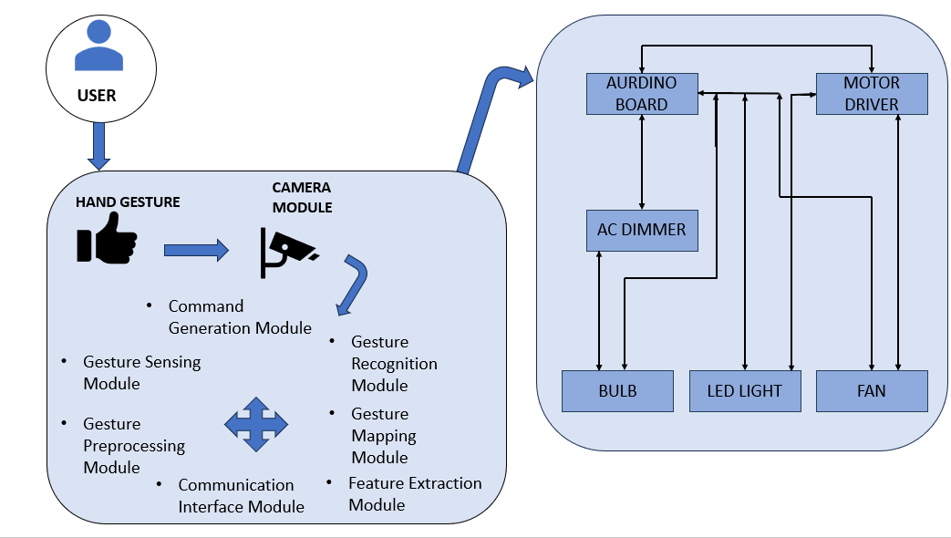

Figure 1. System Configuration Diagram

* Arduino Uno Microcontroller:
* The Arduino Uno serves as the central processing unit of the system, responsible for receiving input signals, processing commands, and controlling the connected hardware components.
* It interfaces with the various sensors and modules, interprets gesture commands received from the gesture recognition algorithm, and generates control signals to adjust the settings of the lights, fan, and other appliances.
* Relay Module for Fan Speed:
* The relay module acts as a switch for controlling the speed of the fan.By receiving control signals from the Arduino Uno, the relay module can toggle between different speed settings of the fan, such as low, medium, or high, allowing users to adjust the airflow according to their comfort level.
* Light, Fan, Bulb:
* These are the primary household appliances that are controlled by the system.
* The light can be turned on/off and its brightness adjusted using the dimmer module, providing customizable lighting options.
* The fan speed can be controlled using the relay module, allowing users to regulate the airflow for optimal comfort.
* The bulb, similar to the light, can be turned on/off and its brightness adjusted based on user preferences.

**Gesture Recognition and Control Workflow:**

The Gesture Recognition and Control Workflow is a crucial aspect of the proposed home-based automation system, responsible for interpreting hand gestures detected by the gesture recognition algorithm and translating them into actionable commands to control household appliances. Below is a detailed overview of this workflow:

* Gesture Detection and Recognition:
* The workflow begins with the detection and recognition of hand gestures using the gesture recognition algorithm, such as the CNN model.
* The algorithm processes input images or frames captured by gesture sensors, extracting features and identifying specific hand gestures based on predefined gesture classes.
* Hand gestures are classified into distinct categories corresponding to different commands or actions that the system can perform, such as turning on/off lights, adjusting fan speed, or activating specific functions of smart devices.
* Command Generation:
* Upon recognizing a specific hand gesture, the gesture recognition algorithm generates corresponding command signals to control the household appliances connected to the system.
* Each recognized gesture is mapped to a predefined command or action, which is then translated into a digital signal or message that instructs the Arduino Uno microcontroller to perform the desired action.
* Arduino Uno Microcontroller Processing:
* The generated command signals are transmitted to the Arduino Uno microcontroller, which serves as the central processing unit of the system.
* The Arduino Uno interprets the received command signals and executes the corresponding actions by sending control signals to the connected hardware components, such as dimmers for light brightness, relay modules for fan speed control, or other actuators.
* Actuator Control:
* The Arduino Uno activates the appropriate actuators based on the received command signals, triggering the desired actions on the connected household appliances.
* For example, if the recognized gesture corresponds to turning on a light, the Arduino Uno sends a signal to the dimmer module to increase the brightness of the light. Similarly, if the gesture is associated with adjusting fan speed, the Arduino Uno adjusts the relay module to control the fan speed accordingly.
* Feedback and Confirmation:
* After executing the commanded action, the system provides feedback to the user to confirm successful execution or to indicate any errors or issues encountered during the process.
* This feedback may be displayed through the user interface, such as LED displays, LCD screens, or auditory cues, informing the user about the current status of the system and the actions performed in response to the recognized gestures.
* Continuous Monitoring and Interaction:
* The workflow continuously monitors for new hand gestures and repeats the process of detection, recognition, and action execution in real-time, enabling seamless and interactive control of household appliances through hand gestures.

**Accessibility Features:**

The proposed home-based automation system incorporates various accessibility features to ensure usability and inclusivity for users with diverse needs. These features are designed to accommodate individuals with mobility impairments or disabilities and enhance their overall user experience. Key accessibility features include:

* Hands-Free Control:
* Hand gestures provide a hands-free control option, eliminating the need for physical switches, remote controls, or manual interactions with devices.
* This feature enables individuals with mobility impairments or disabilities to interact with the system effortlessly, without requiring fine motor skills or dexterity.
* Voice Commands:
* The system may support voice commands as an alternative control mechanism, allowing users to verbally command the system to perform various actions.
* Voice recognition technology interprets spoken commands and translates them into actionable instructions for controlling household appliances.
* Tactile Feedback:
* Tactile feedback mechanisms, such as vibration alerts or haptic feedback, may be integrated into the user interface to provide users with tactile cues or confirmation of gesture recognition.
* These feedback mechanisms enhance user interaction and provide users with sensory feedback, particularly beneficial for individuals with visual impairments.
* Customizable Gestures:
* The system may offer the flexibility to customize gesture mappings according to individual preferences or accessibility needs.
* Users can define their own set of gestures and assign specific actions to each gesture, allowing for personalized interaction with the system.
* Accessible User Interface:
* The user interface is designed to be accessible and user-friendly, with clear and intuitive visual indicators, large fonts, and high contrast for improved visibility.
* Accessibility standards, such as the Web Content Accessibility Guidelines (WCAG), may be followed to ensure compliance with accessibility requirements.
* Compatibility with Assistive Technologies:
* The system is compatible with assistive technologies such as screen readers, switch controls, or alternative input devices commonly used by individuals with disabilities.
* This compatibility ensures that users can seamlessly integrate the home automation system into their existing assistive technology setups, enhancing accessibility and usability.

**Optimization and Performance:**

Optimization and performance are crucial aspects of the proposed home-based automation system using hand gestures. These aspects ensure that the system operates efficiently, responds promptly to user input, and delivers a seamless user experience. Here's a detailed overview of optimization and performance considerations:

* Algorithm Optimization:
* The gesture recognition algorithm undergoes optimization to improve inference speed, reduce computational complexity, and enhance accuracy.
* Techniques such as model pruning, quantization, and compression are applied to reduce the size of the neural network model without compromising performance.
* Efficient architecture designs and algorithmic optimizations are implemented to minimize the number of operations and parameters required for gesture recognition.
* Hardware Acceleration:
* Hardware acceleration techniques, such as using specialized hardware accelerators like GPUs or TPUs, are employed to speed up inference and reduce processing time.
* The use of dedicated hardware accelerators offloads computational tasks from the main CPU, allowing for faster and more efficient execution of the gesture recognition algorithm.
* Real-Time Processing:
* The system is optimized for real-time processing to ensure that gesture recognition and appliance control occur with minimal latency.
* Parallel processing techniques, multi-threading, and efficient data pipelines are implemented to handle the simultaneous capture, processing, and execution of multiple gestures in real-time.
* Hardware Configuration:
* The hardware components, including the Arduino Uno microcontroller and peripheral devices, are configured and optimized for optimal performance.
* Careful selection of hardware components based on processing power, memory, and connectivity ensures that the system can efficiently handle the computational demands of gesture recognition and control tasks.
* System Calibration:
* The system undergoes calibration to fine-tune parameters and optimize performance for specific environmental conditions.
* Calibration procedures may include adjusting camera settings, sensor sensitivity, and threshold values to ensure accurate gesture recognition and reliable operation in various lighting and background conditions.
* User Feedback and Confirmation:
* Feedback mechanisms are incorporated into the user interface to provide users with real-time feedback and confirmation of gesture recognition and appliance control.
* Visual indicators, auditory signals, or haptic feedback are used to notify users of successful execution of commands or any errors encountered during the process, enhancing user confidence and trust in the system.
* Performance Evaluation:
* The performance of the system is rigorously evaluated using metrics such as recognition accuracy, response time, throughput, and system reliability.
* Benchmarking tests are conducted under different scenarios and load conditions to assess the system's performance and identify areas for improvement.

2.2 Proposed System Efficiency

The proposed system efficiency hinges on a meticulous balance of hardware optimization, algorithmic prowess, and user-centric design. By leveraging advanced gesture recognition algorithms and hardware components, the system achieves real-time responsiveness and low latency, ensuring prompt execution of user commands. Optimization techniques, including hardware acceleration and algorithmic refinement, enhance resource utilization and minimize power consumption, promoting energy efficiency. The system's scalability enables seamless integration with additional devices, while its intuitive user interface and accessibility features ensure usability for users of all abilities. Furthermore, performance monitoring mechanisms continually evaluate system metrics, facilitating proactive optimization and maintenance. Collectively, these elements culminate in a highly efficient home automation system that delivers seamless control of household appliances while prioritizing reliability, accessibility, and user satisfaction.

Table 2.1 System Efficiency compared in a tabular format

|  |  |
| --- | --- |
| Efficiency Aspect | Description |
| Real-Time Responsiveness | The system is optimized to recognize hand gestures and control household appliances in real-time, ensuring prompt response to user commands. |
| Low Latency | Optimization techniques such as hardware acceleration, parallel processing, and algorithmic optimizations minimize latency in gesture recognition and appliance control. |
| Resource Optimization | Efficient use of memory, processing power, and energy consumption minimizes resource wastage and extends the lifespan of system components. |
| Scalability | The system is designed to seamlessly integrate additional devices, sensors, or functionalities, allowing for future expansions without compromising performance. |
| User-Friendly Interface | Intuitively designed user interface with accessibility features, clear feedback mechanisms, and customizable settings enhances user engagement and efficiency. |
| Reliability and Robustness | Robust gesture recognition algorithms, error handling mechanisms, and redundancy measures ensure uninterrupted functionality under various conditions. |
| Energy Efficiency | Energy-efficient hardware components and optimization techniques minimize power consumption and environmental impact while maintaining system responsiveness. |

2.3 List of Modules

1. **Gesture Recognition Module:** Implements the gesture recognition algorithm, such as CNN for detecting and classifying hand gestures in real-time.
2. **Sensor Interface Module:** Manages communication with gesture sensors, such as cameras or depth sensors, to capture hand movements and provide input to the gesture recognition algorithm.
3. **Command Generation Module:** Generates actionable commands based on recognized gestures, mapping each gesture to specific actions or control signals for household appliances.
4. **Arduino Uno Interface Module:** Interfaces with the Arduino Uno microcontroller to transmit command signals from the gesture recognition module to connected hardware components.
5. **Hardware Control Module:** Controls household appliances and devices, such as lights, fans, and smart switches, based on received command signals from the Arduino Uno interface module.
6. **Calibration and Configuration Module:** Allows users to calibrate and configure the system parameters, such as gesture sensitivity, device mappings, and user preferences.
7. **Accessibility Features Module:** Implements accessibility features, such as voice commands, tactile feedback, and customizable gestures, to enhance usability for users with diverse needs.
8. **Performance Monitoring Module:** Monitors system performance metrics, such as gesture recognition accuracy, response time, and resource utilization, to ensure efficient operation.
9. **Energy Management Module:** Optimizes energy consumption and power usage of the system components, implementing power-saving modes and intelligent scheduling algorithms to conserve energy.

2.4 Explanation

1. **Gesture Recognition Module:**

* This module is responsible for detecting and recognizing hand gestures captured by gesture sensors.
* It employs advanced algorithms, such as CNN, to process input images or frames in real-time and classify them into predefined gesture categories.

1. **Sensor Interface Module:**

* The Sensor Interface Module serves as the interface between the gesture sensors and the gesture recognition algorithm.
* It captures hand gestures using sensors such as cameras, depth sensors, or infrared sensors strategically placed within the environment.

1. **Command Generation Module:**

* The Command Generation Module is responsible for translating recognized gestures into actionable commands for controlling household appliances.
* Upon receiving gesture inputs from the Gesture Recognition Module, this module processes the data and generates corresponding commands based on predefined mappings.

1. **Arduino Uno Interface Module:**

* Acting as the bridge between the gesture recognition algorithm and hardware components, the Arduino Interface Module receives gesture commands from the recognition module.
* It processes these commands and translates them into control signals compatible with the Arduino Uno microcontroller, which interfaces with the connected hardware devices.

1. **Hardware Control Module:**

* Acting as the bridge between the gesture recognition algorithm and hardware components, the Arduino Interface Module receives gesture commands from the recognition module.
* It processes these commands and translates them into control signals compatible with the Arduino Uno microcontroller, which interfaces with the connected hardware devices.

1. **Calibration and Configuration Module:**

* Acting as the bridge between the gesture recognition algorithm and hardware components, the Arduino Interface Module receives gesture commands from the recognition module.
* It processes these commands and translates them into control signals compatible with the Arduino Uno microcontroller, which interfaces with the connected hardware devices.

1. **Accessibility Features Module:**

* The Accessibility Module enhances usability and accessibility for users with diverse needs.
* It incorporates features such as voice commands, tactile feedback, and customizable user interfaces to accommodate a wide range of user preferences and capabilities.

1. **Performance Monitoring Module:**

* The Performance Monitoring Module is responsible for continuously monitoring the system's performance and ensuring optimal operation.
* It tracks various performance metrics, including gesture recognition accuracy, response time, system throughput, and resource utilization.

**Chapter 3**

### Implementation

3.1 CODE AND EXPLANATION

#### CAPTURE.py:

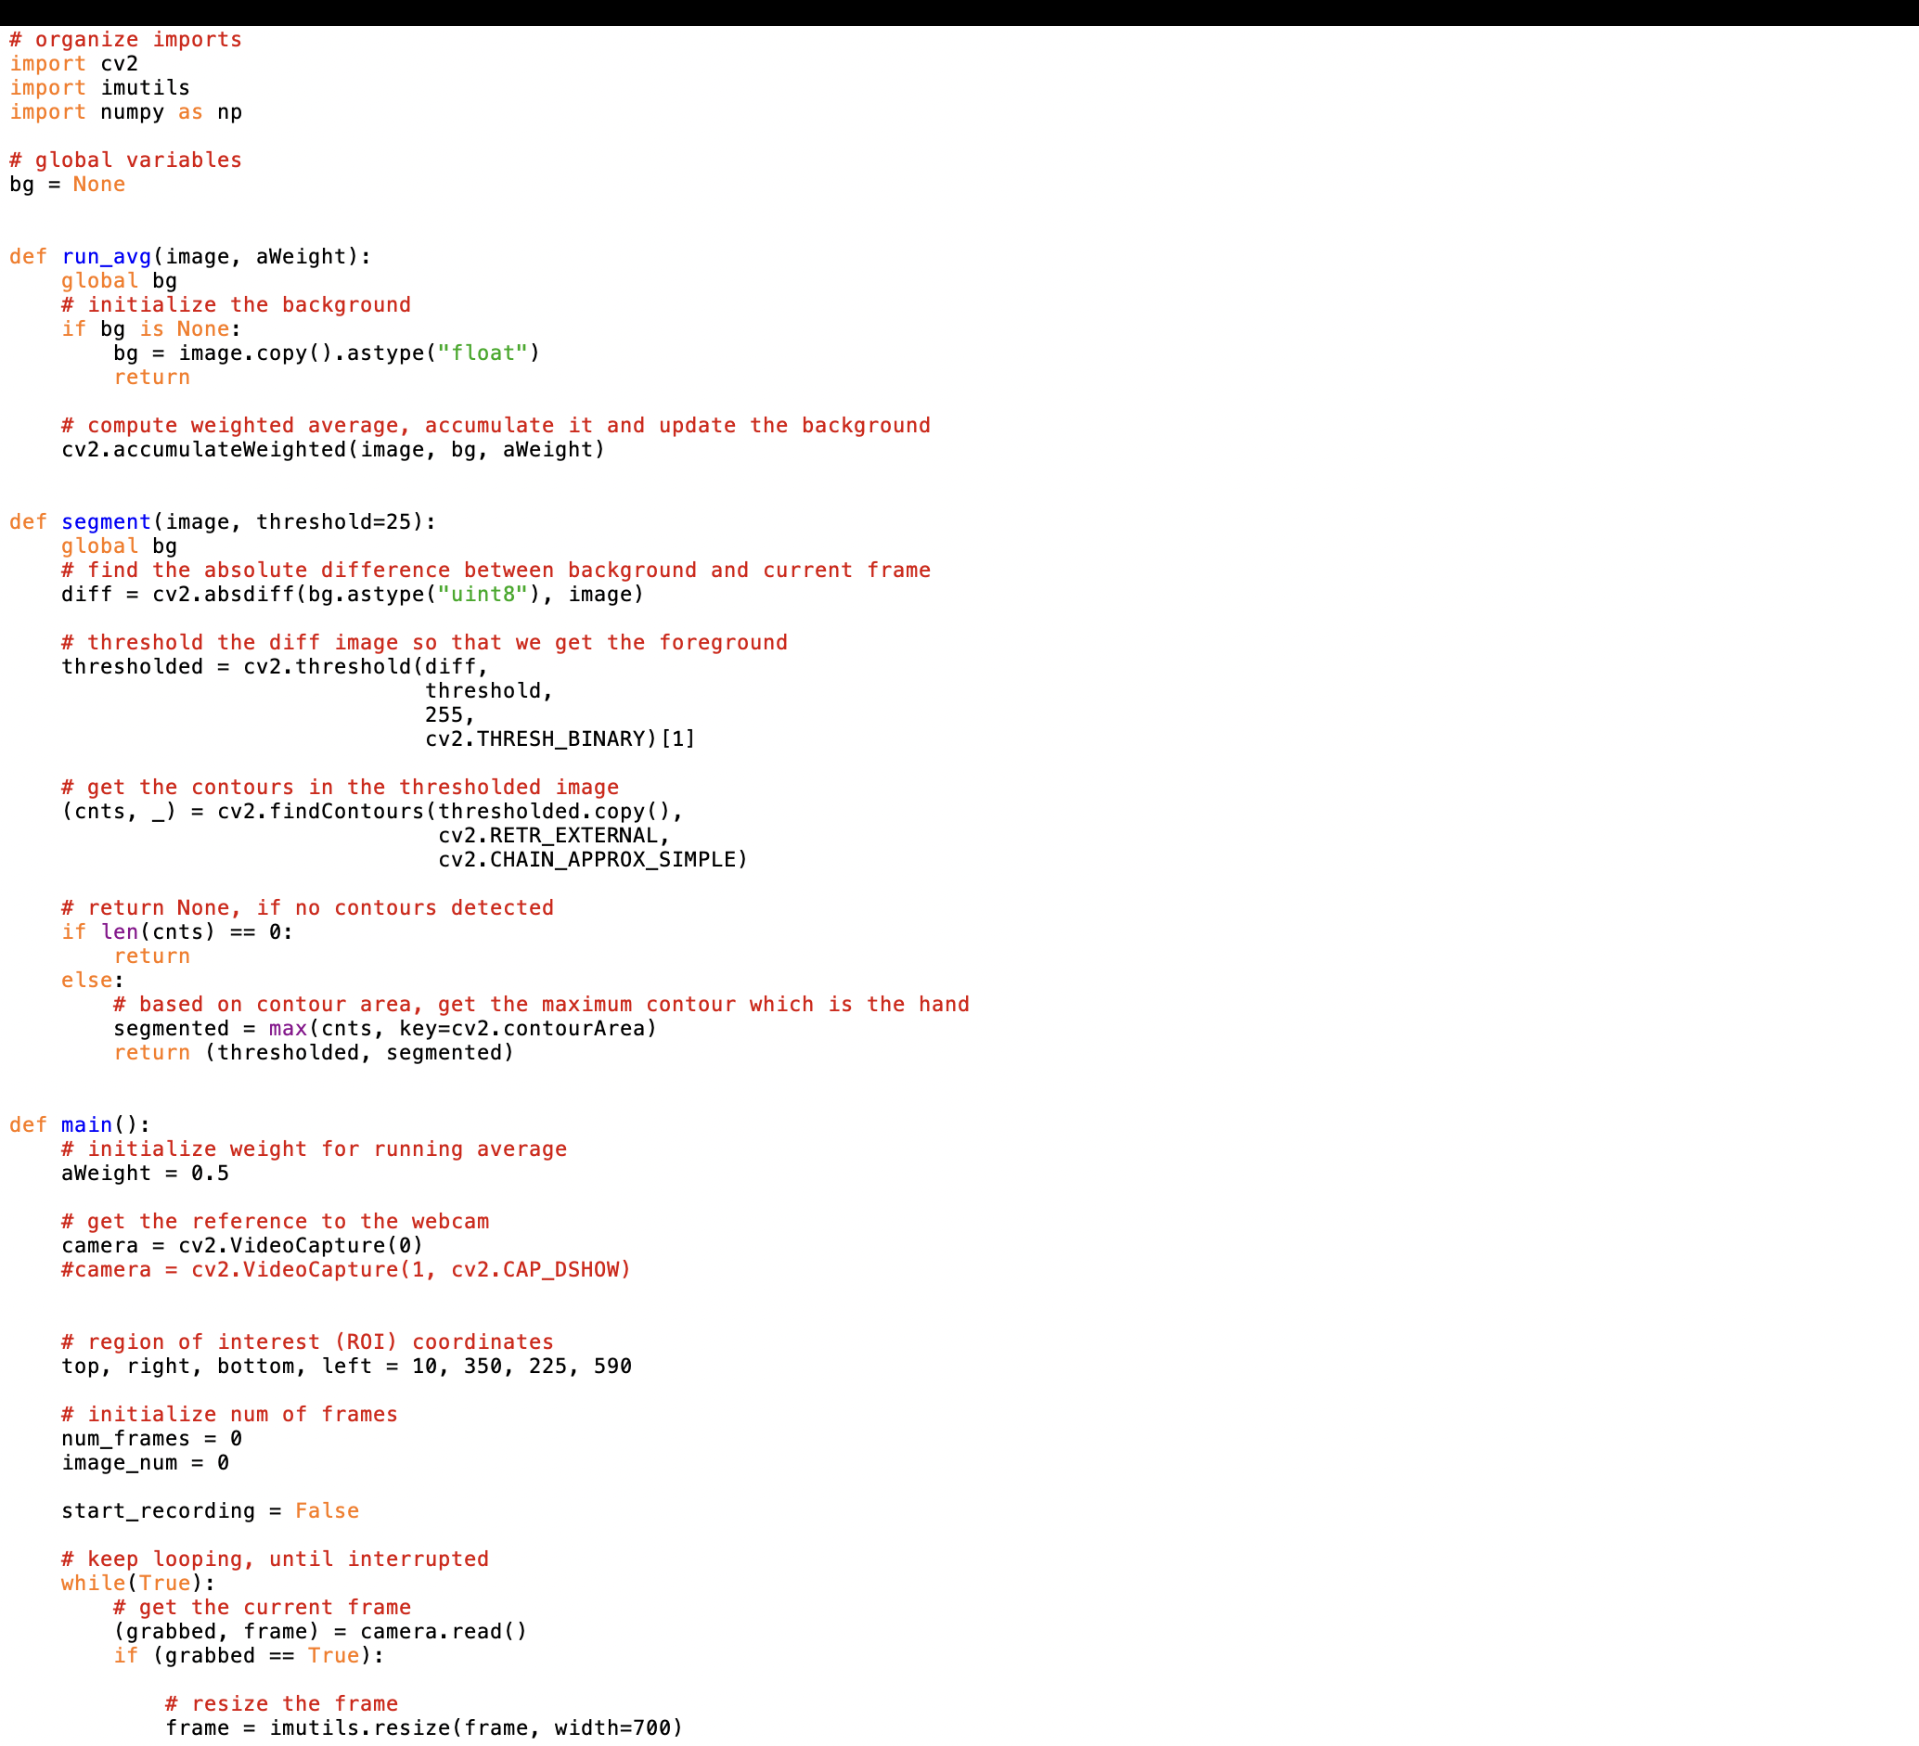

Figure 2. Capture.py

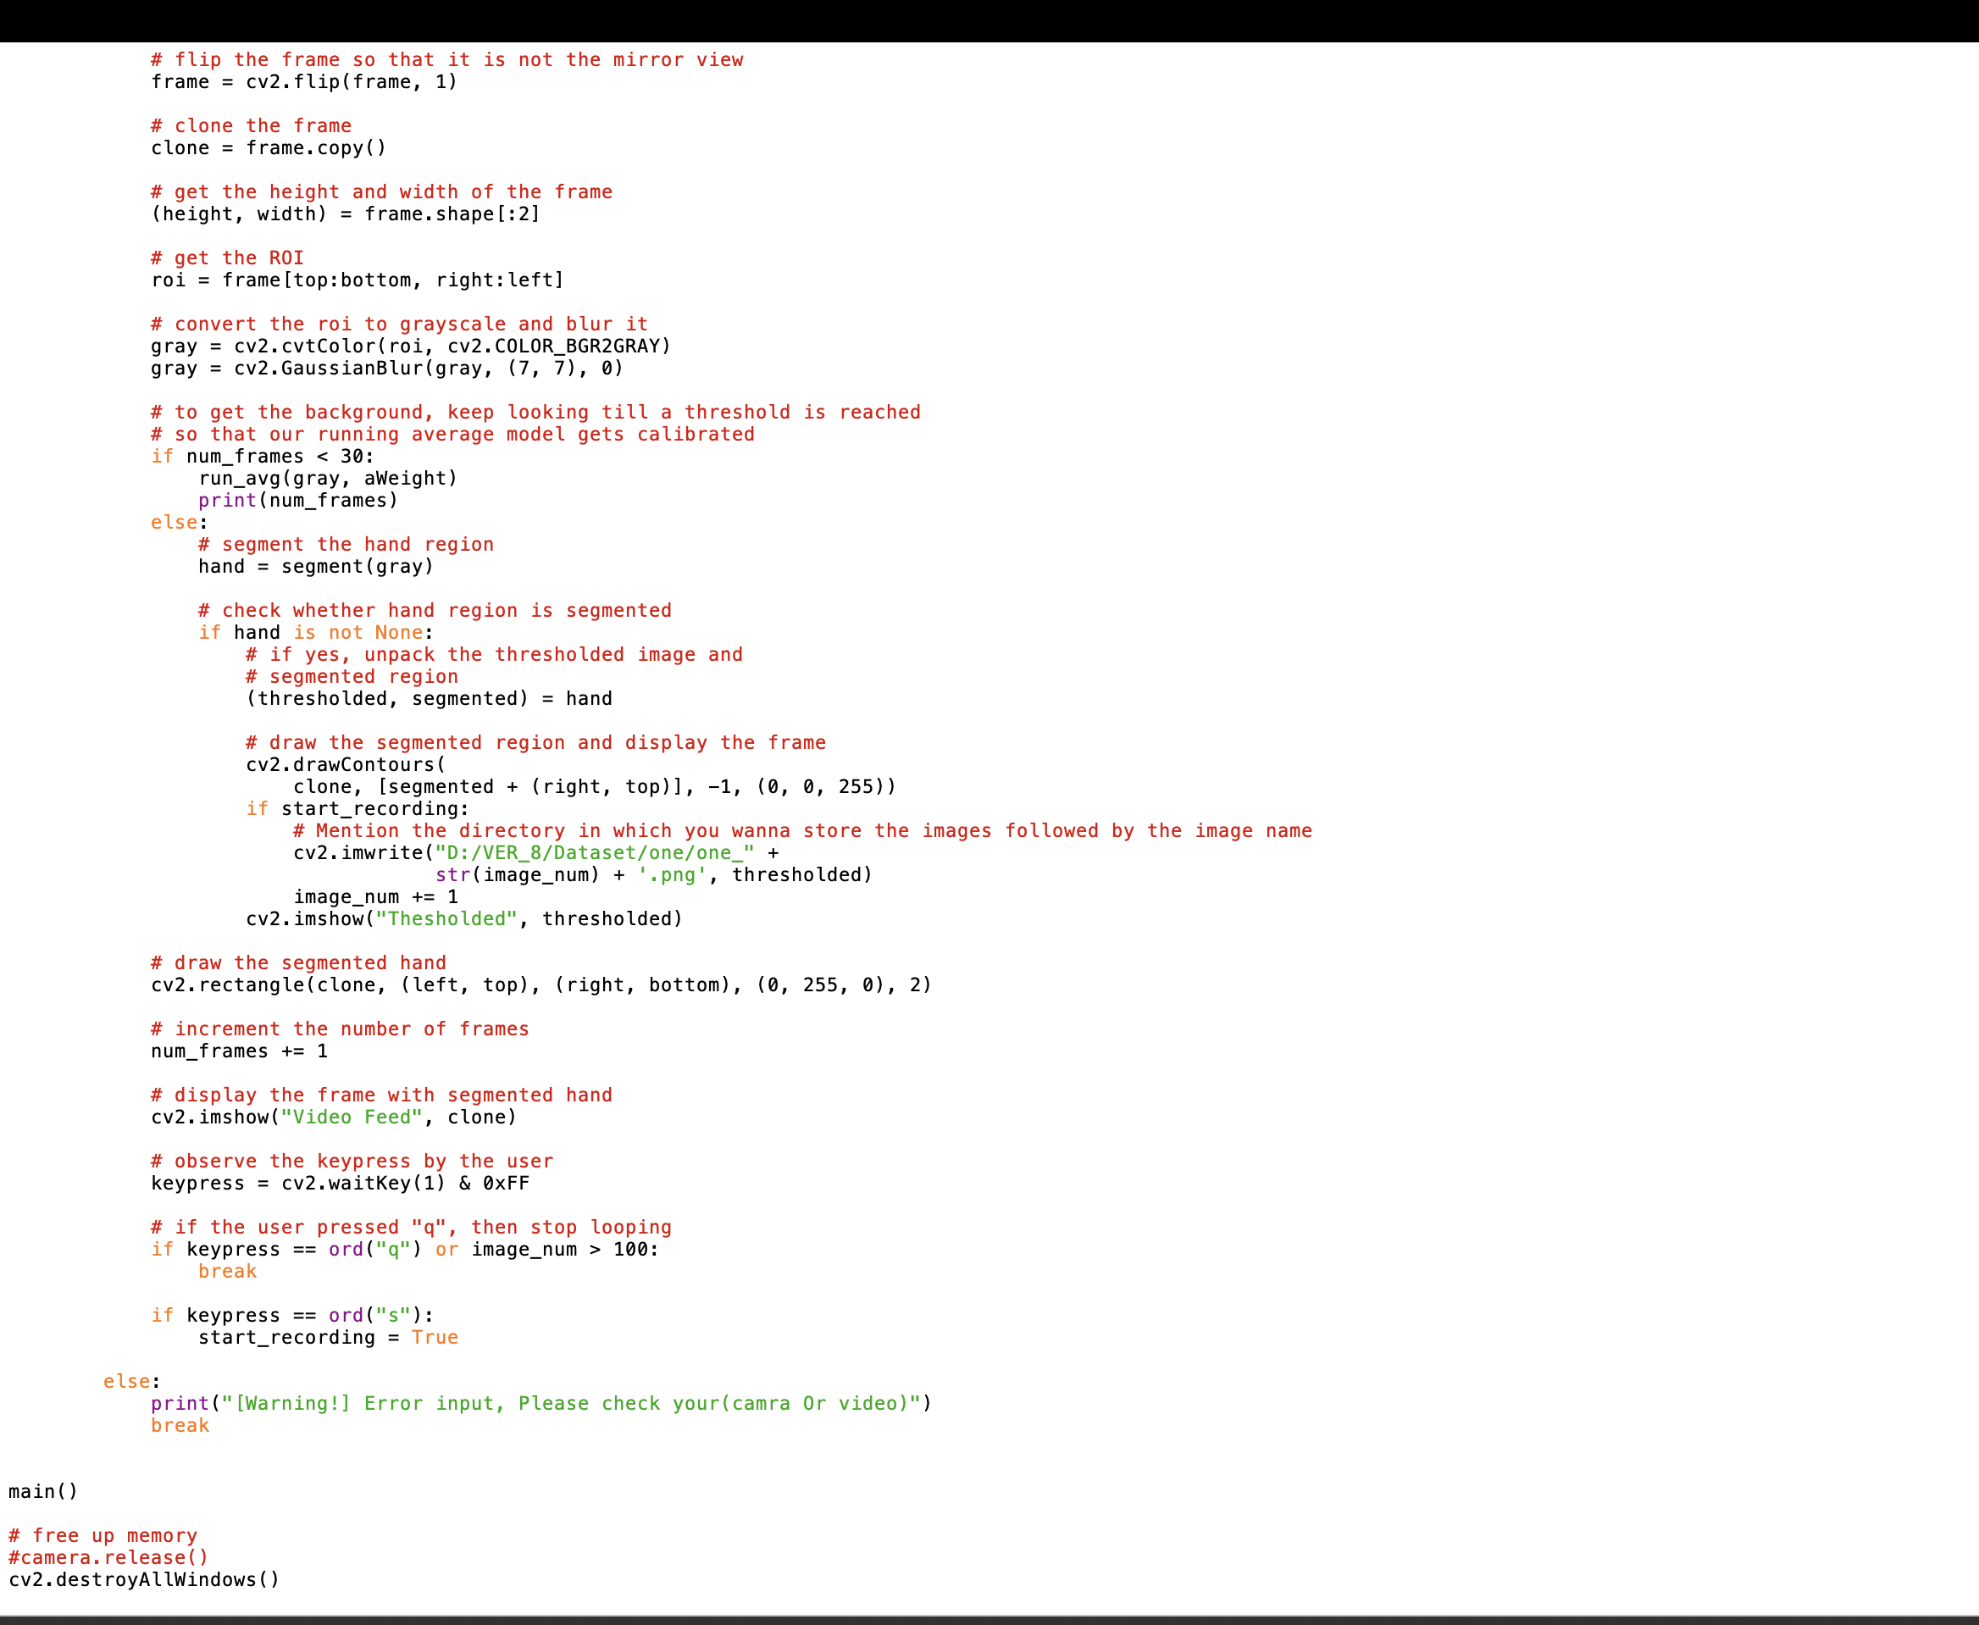

Figure 2. Capture.py

Explanation:

* import cv2: Importing the OpenCV library for computer vision tasks.
* import numpy as np: Importing NumPy library for numerical computations.
* from unified_detector import Fingertips: Importing the Fingertips class from the unified_detector module.
* from hand_detector.detector import Importing the classes from the detector module within the hand_detector package.
* import serial: Importing the serial module for serial communication.
* from time import sleep: Importing the sleep function from the time module.
* Defined several functions detected(), detected2(), detected3(), detected4(), and detected5(), each initiating serial communication, sending a specific character, sleeping for 1 second, and printing a message.
* hand_detection_method = 'CNN': Setting the variable hand_detection_method to , indicating the method for hand detection to be used.
* Conditional statements to initialize the hand detector based on the selected method
* Initializing the Fingertips object with specified weights.
* Initializing the webcam capture (VideoCapture object) with the default camera (index 0).
* Printing a message indicating the start of unified gesture and fingertips detection.
* Entering a while loop to continuously capture frames from the webcam until the user exits.
* Reading a frame from the webcam.
* Checking if the frame is successfully captured (ret is True).
* Detecting the hand region in the captured image.
* If hand region is detected, cropping the image to the hand region and extracting relevant features for fingertips detection.
* Counting the number of fingers detected.
* Drawing rectangles around the detected hand region and displaying the finger count on the frame.
* Checking the finger count and calling corresponding detected() functions accordingly.
* Exiting the loop if the 'Esc' key is pressed.
* Releasing the webcam capture and closing all OpenCV windows.

#### TRAINING.py:



Figure 3. training.py

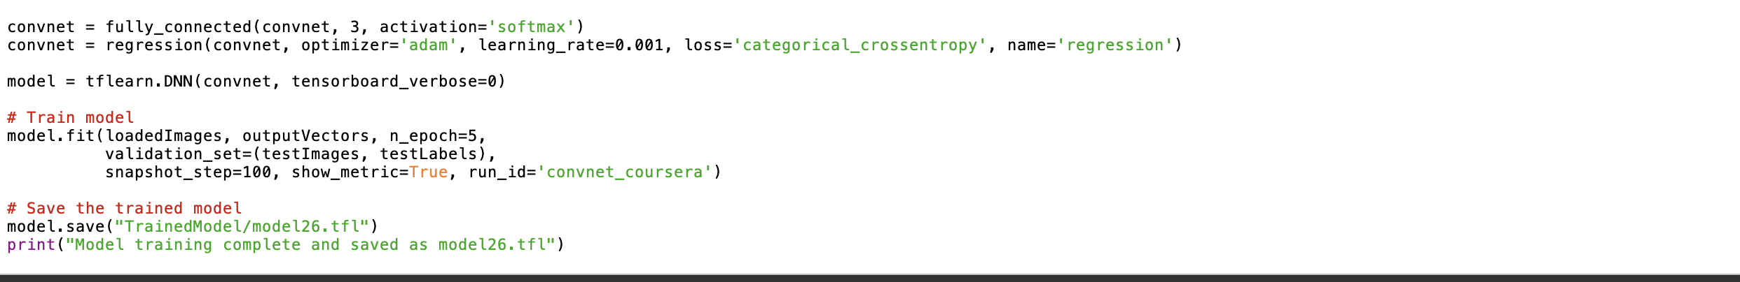

Figure 3. training.py

Explanation:

* Imports necessary libraries and modules including TensorFlow, OpenCV, and custom modules for neural network architecture, data generators, and callbacks.
* Defines two custom loss functions for a neural network: one for probabilistic output and another for positional output.
* Creates a neural network model using a custom architecture.
* Compiles the model with the Adam optimizer and the custom loss functions.
* Sets up training parameters such as the number of epochs, batch size, and sizes of the training and validation datasets.
* Generates data using custom data generators for training and validation.
* Configures a Model Checkpoint callback to save the model weights after each epoch during training.
* Trains the model using the fit method, specifying training and validation data generators, along with other training parameters.
* Prints a message indicating the completion of training.

#### TESTING.py:

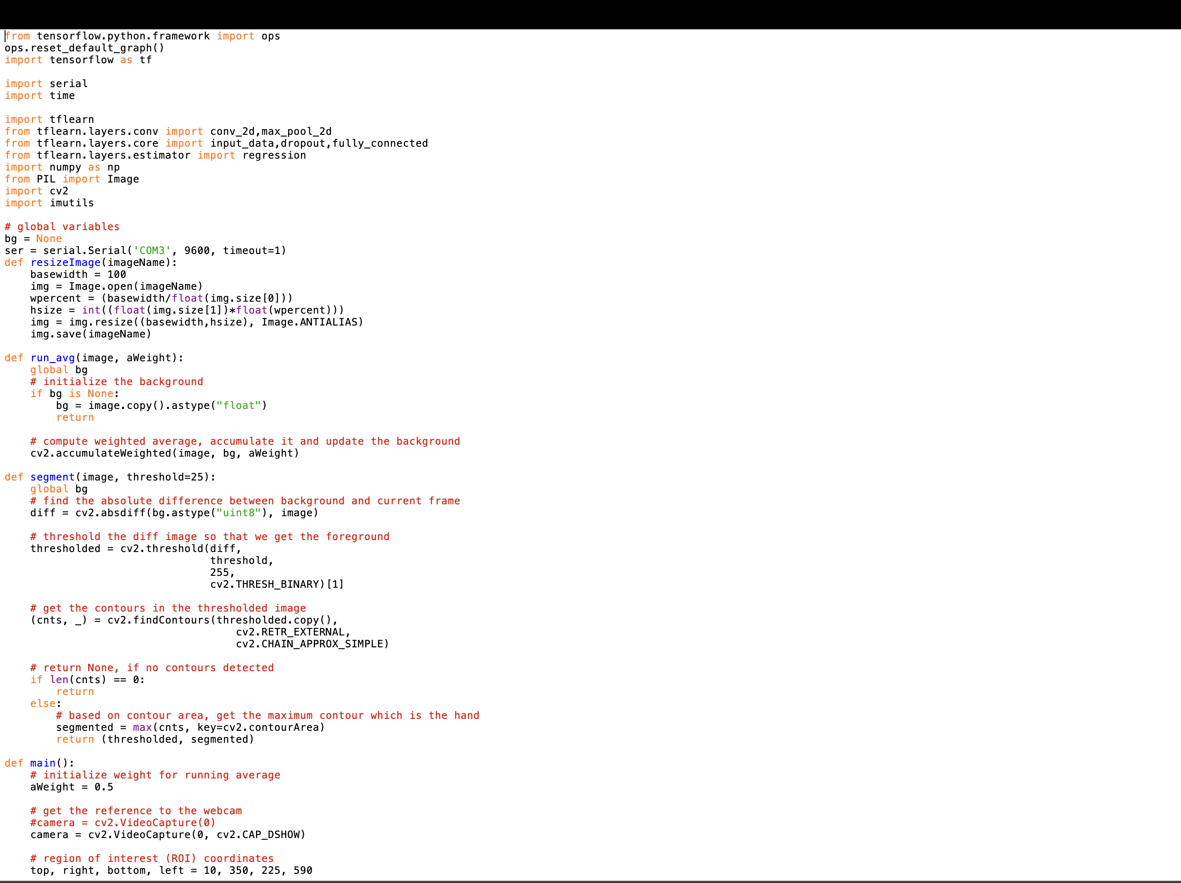

Figure 4. testing.py

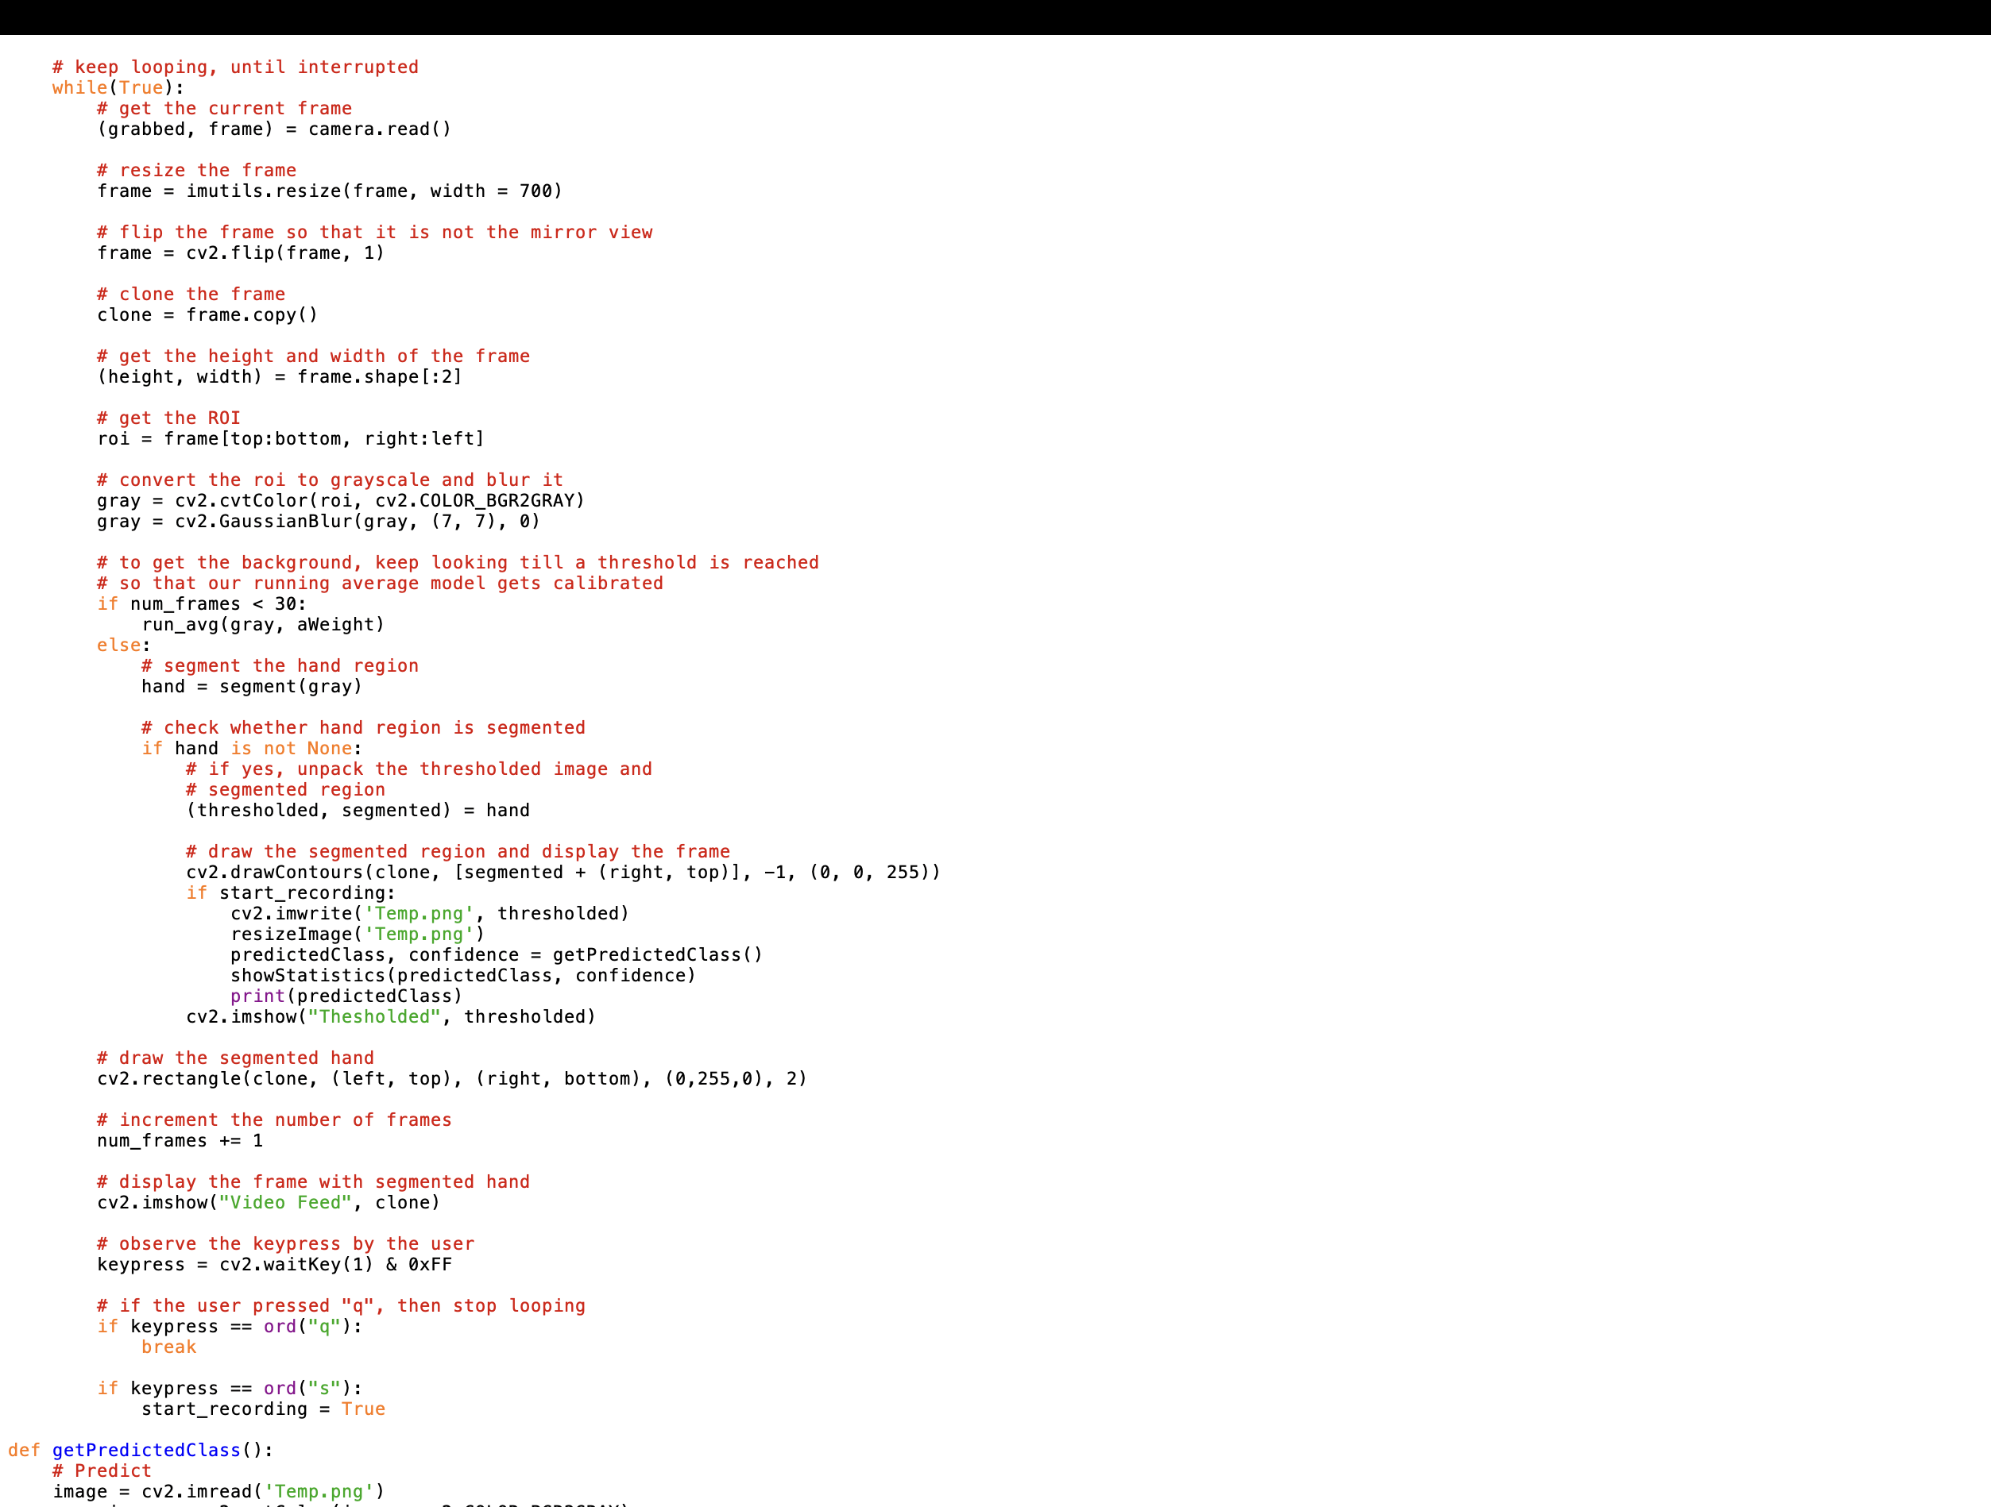

Figure 4. testing.py

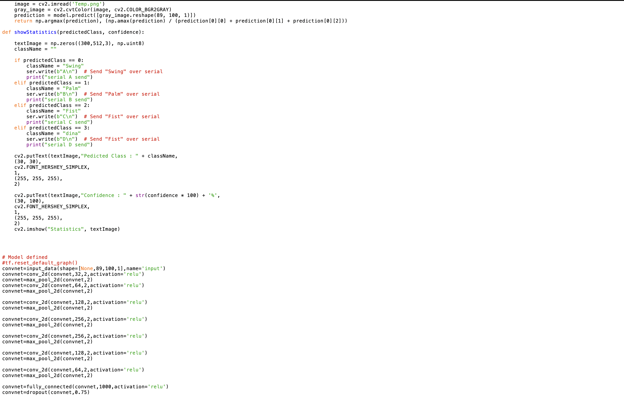

Figure 4. testing.py

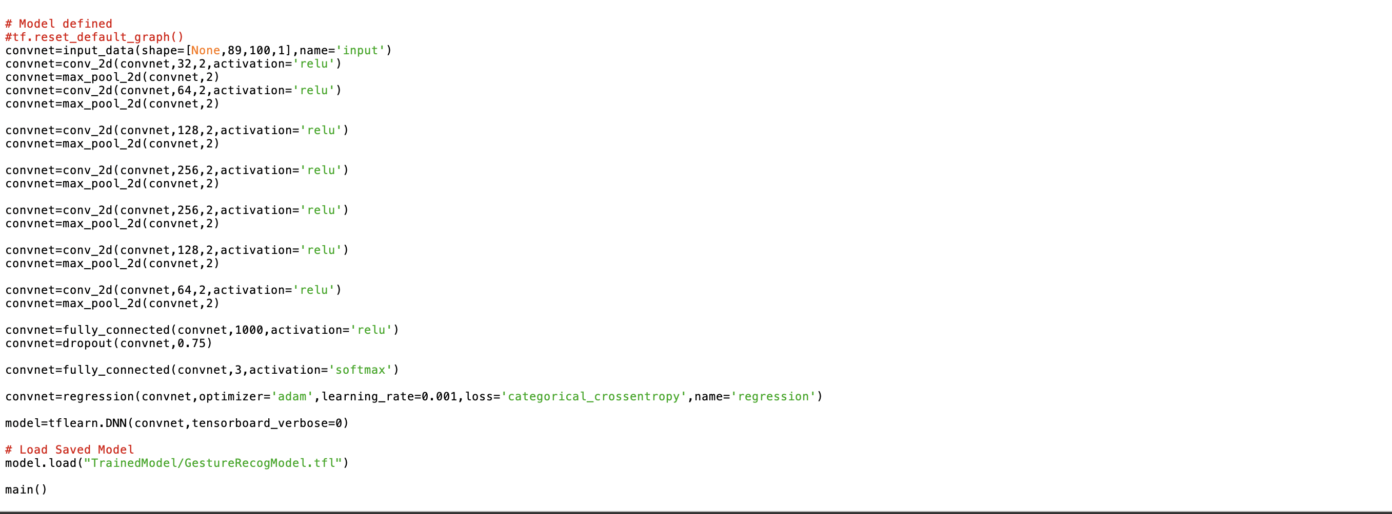

Figure 4. testing.py

Explanation:

* cv2: Library for computer vision tasks.
* numpy as np: Library for numerical computations.
* model from net.network: Importing a neural network model from a custom module.
* Constructor (__init__): Initializes the Fingertips object with the provided weights for the neural network model and loads these weights into the model.
* Method class_finder: A static method that determines the class of the gesture based on the input probability array. It compares the input probability array with predefined patterns and assigns the corresponding class.
* Method classify: Takes an image as input and performs classification. It resizes the input image to (128, 128), normalizes it, and prepares it for input to the neural network model. It then predicts the probability and position of the gesture using the loaded model.

#### VISUALIZE.py:

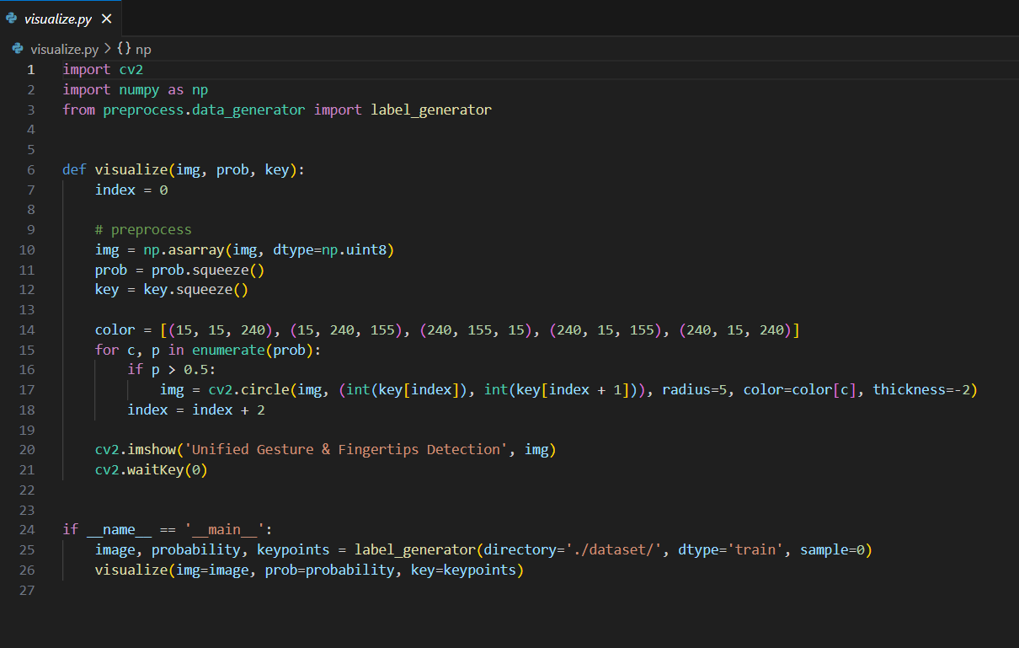

Figure 5. visualize.py

Explanation:

* cv2: OpenCV library for computer vision tasks.
* numpy as np: NumPy library for numerical computations.
* label_generator from preprocess.data_generator: Importing a function for generating labeled data from a custom module.
* Takes three parameters: img (image), prob (probability), and key (keypoints).
* Converts the image and ensures it's of type uint8.
* Reshapes the probability and keypoint arrays.
* Defines colors for different gestures.
* Iterates through each gesture probability, drawing circles on the image for each detected fingertip.
* Displays the modified image using cv2.imshow.
* Waits for a key press (cv2.waitKey(0)) before closing the window.
* Generates labeled data (image, probability, keypoints) using the label_generator function from the specified directory and data type (train/test), and a specific sample index (0 in this case).
* Calls the visualize function with the generated data as arguments, displaying the image with overlaid circles representing detected fingertips.

#### GENERATOR.py:

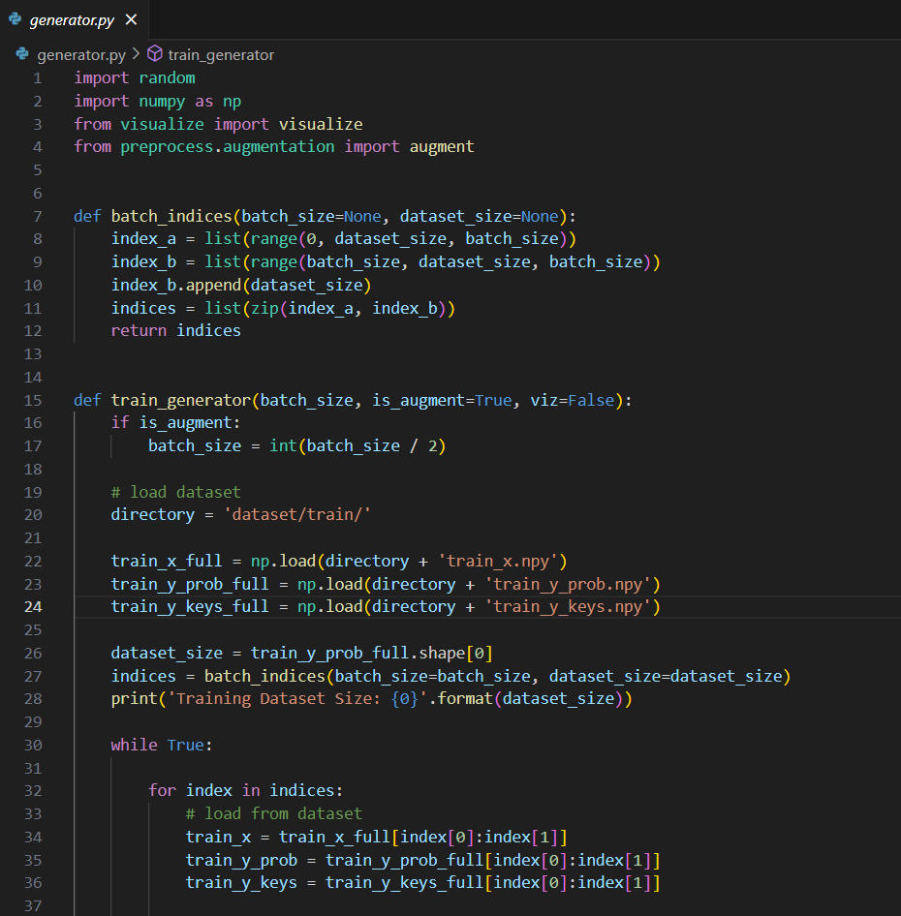Figure 7. generator.py

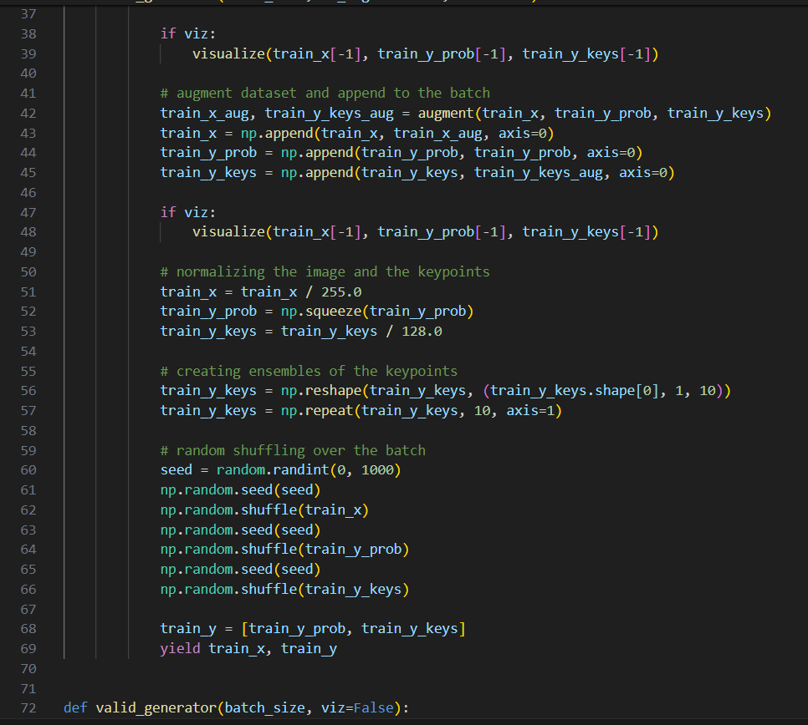

Figure 7. generator.py

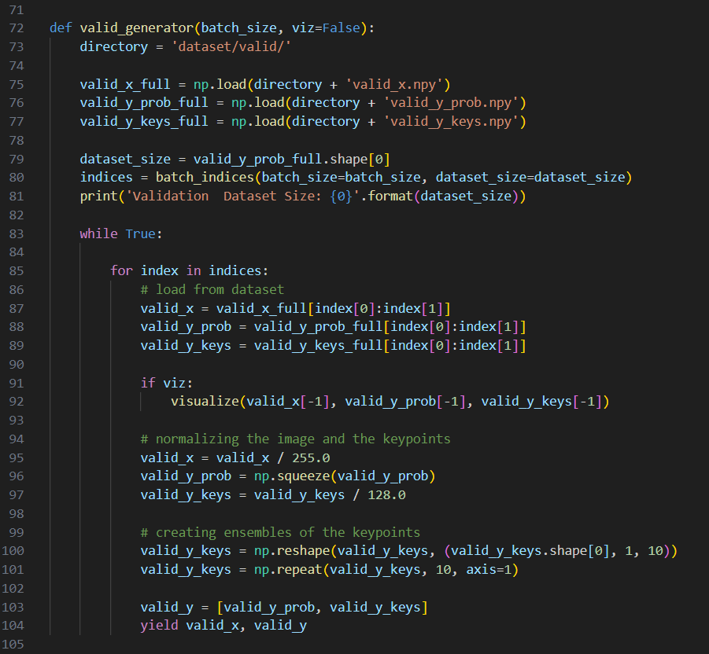

Figure 7. generator.py

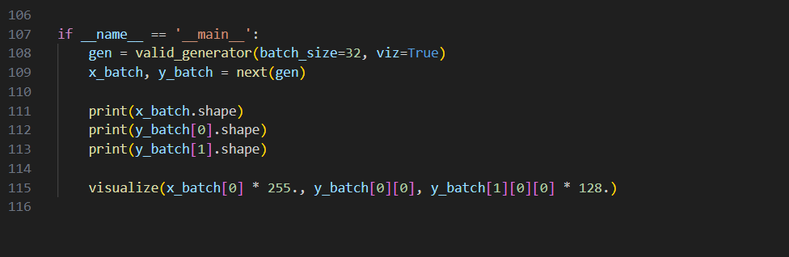

Figure 7. generator.py

Explanation:

The provided code defines two generator functions, train_generator and valid_generator, used for generating batches of training and validation data, respectively. random: Library for generating random numbers.

* numpy as np: NumPy library for numerical computations.
* visualize from visualize: Importing a visualization function for displaying images with labels.
* augment from preprocess.augmentation: Importing a function for data augmentation.
* Generates batch indices for iterating over the dataset in batches.
* Generates batches of training data.
* Loads the training dataset.
* Divides the dataset into batches and yields augmented data.
* Normalizes image data and reshapes keypoints.
* Shuffles the data within each batch.
* Yields batches of images and their corresponding labels.
* Generates batches of validation data.
* Loads the validation dataset.
* Divides the dataset into batches and yields data.
* Normalizes image data and reshapes keypoints.
* Yields batches of images and their corresponding labels.
* Tests the valid_generator function by generating a batch of data.
* Prints the shapes of the generated batches.
* Visualizes the first sample in the generated batch.

3.1.2 Arduino IDE :

#### Home_automation.ino:

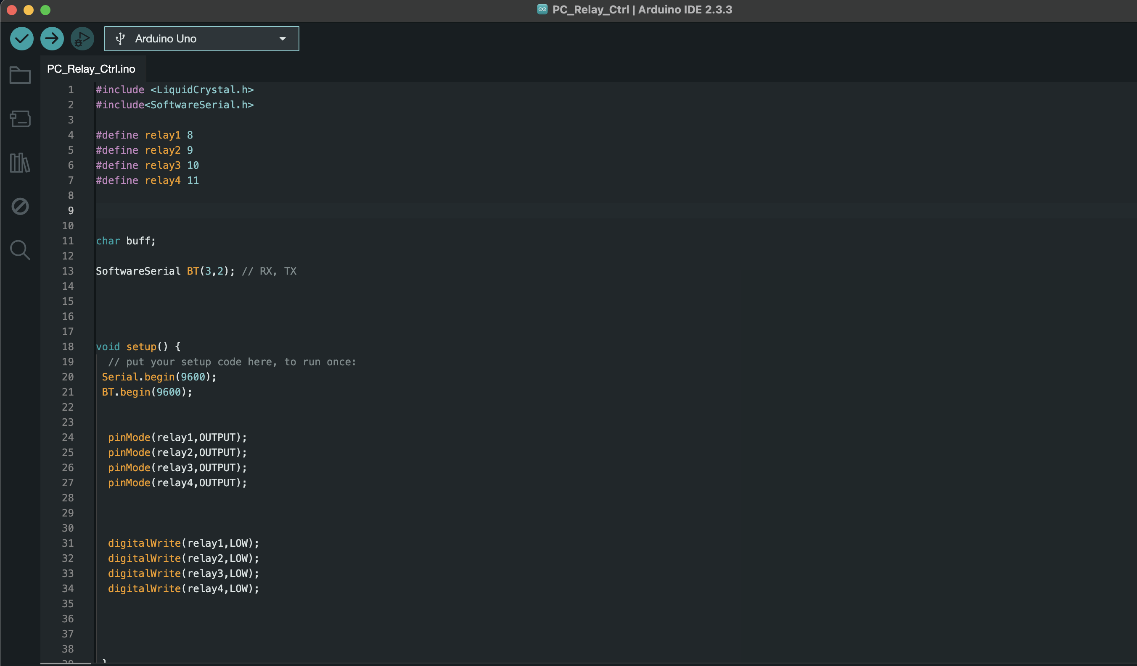

Figure 8. Home_automation.ino



Figure 8. Home_automation.ino

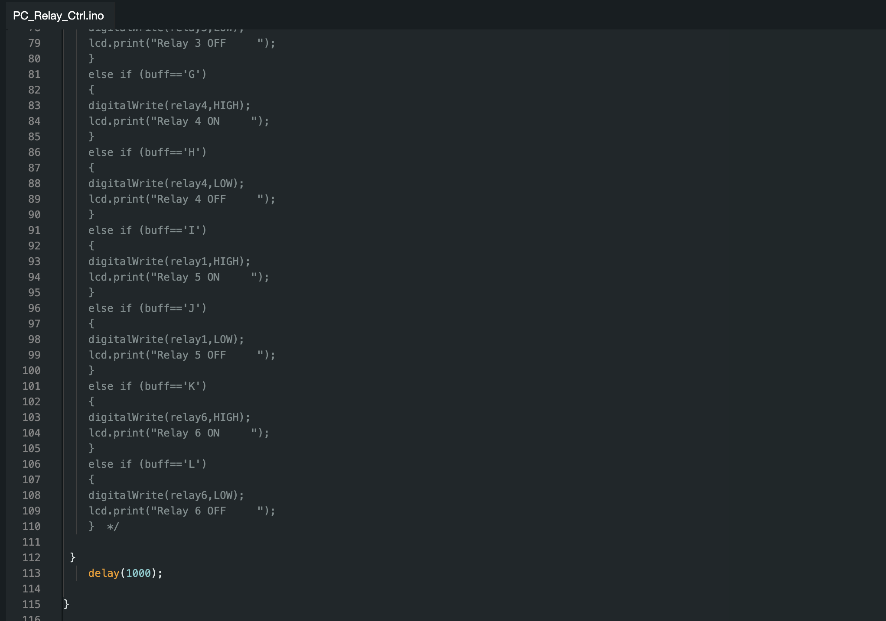

Figure 8. Home_automation.ino

Explanation:

This Arduino code controls various devices based on voice commands received over a serial connection.

* #include <SoftwareSerial.h>: Importing the SoftwareSerial library for serial communication.
* #define USE_SERIAL Serial: Defining USE_SERIAL as Serial for serial communication.
* #define outputPin 12: Defining the output pin for the dimmer.
* #define zerocross 2: Defining the zerocross pin for the dimmer.
* dimmerLamp dimmer(outputPin);: Initializing a dimmerLamp object named dimmer with the outputPin.
* char voice;: Declaring a variable to store received voice commands.
* int char = 0;: Declaring an integer variable with the name char, which is set to 0. Note: char is a reserved keyword in C++ and cannot be used as a variable name.
* const int IN1 = 5;, const int IN2 = 6;, const int IN3 = 9;, const int IN4 = 10;: Defining digital pins for controlling devices.
* void setup(): The setup function, called once when the Arduino starts.
* dimmer.begin(NORMAL_MODE, ON);: Initializing the dimmer in normal mode with the initial state as ON.
* dimmer.setState(OFF);: Turning off the dimmer.
* pinMode(IN1, OUTPUT);, pinMode(IN2, OUTPUT);, pinMode(IN3, OUTPUT);, pinMode(IN4, OUTPUT);: Setting digital pins as output.
* Serial.begin(9600);: Starting serial communication at a baud rate of 9600.
* analogWrite(IN1, 0);, analogWrite(IN2, 0);, analogWrite(IN3, 0);, analogWrite(IN4, 0);: Setting analog outputs to 0.
* Serial.print("Start");: Printing "Start" to serial output.
* delay(1000);: Adding a delay of 1000 milliseconds (1 second).
* void loop(): The loop function, continuously executed after the setup function.
* if (Serial.available() > 0): Checking if there is serial data available to read.
* voice = "";: Initializing the voice variable as an empty string.
* delay(2);: Adding a small delay for stability.
* voice = Serial.read();: Reading the serial input and storing it in the voice variable.
* delay(2);: Adding a small delay for stability.
* Serial.println(voice);: Printing the received voice command.
* if (voice == "a" || voice == 'a'): Checking if the received voice command is 'a'.
* Serial.println("DETEC");: Printing "DETEC" to serial output.
* analogWrite(IN1, 0);, analogWrite(IN2, 204);: Setting analog outputs for motor control.
* else if (voice == "b" || voice == 'b'): Checking if the received voice command is 'b'.
* Executing motor control commands similar to those for command 'a'.

The rest of the code follows a similar structure, checking for other voice commands ('c', 'd', 'e') and executing corresponding actions.

3.2 Results

The hardware setup for our home-based automation system using hand gestures is crucial for translating recognized gestures into actionable commands that control household appliances. Below is an explanation of the key components and their roles in the hardware setup:

**Arduino Uno Microcontroller:**

* The Arduino Uno serves as the central control unit of the system, responsible for receiving gesture commands from the gesture recognition algorithm and translating them into control signals for connected devices.
* Its versatility and ease of programming make it an ideal choice for interfacing with various sensors and actuators in the hardware setup.

**Relay Module:**

* The relay module is used to control high-power electrical appliances such as lights, fans, or other household devices.
* It consists of one or more relays, each capable of switching the electrical power supply to a connected appliance on or off in response to signals from the Arduino Uno.

**Dimmer Module:**

* The dimmer module is employed for controlling the brightness of light fixtures such as LED bulbs or incandescent bulbs.
* It utilizes pulse-width modulation (PWM) techniques to adjust the voltage supplied to the connected bulb, thereby regulating its brightness level based on commands from the Arduino Uno.

**Motor Driver:**

* The motor driver module is utilized to control the speed of a motor, typically found in devices like fans or other mechanical systems.
* It interprets signals from the Arduino Uno and adjusts the voltage and current supplied to the motor to achieve the desired speed level.

**Gesture Sensors:**

* Gesture sensors, such as cameras, infrared sensors, or depth sensors, capture hand movements and transmit data to the gesture recognition algorithm for processing.
* These sensors are strategically placed within the environment to capture hand gestures effectively and enable real-time interaction with the system.

**Power Supply:**

* A stable and reliable power supply is essential to ensure the proper functioning of the hardware components.
* Depending on the specific requirements of the system, a regulated DC power supply or batteries may be used to provide power to the Arduino Uno and other components.

**Connectors and Wiring:**

* Connectors and wiring are used to establish electrical connections between the Arduino Uno, relay module, dimmer module, motor driver, gesture sensors, and other hardware components.
* Proper wiring and connection management are crucial to ensure reliable communication and operation of the hardware setup.

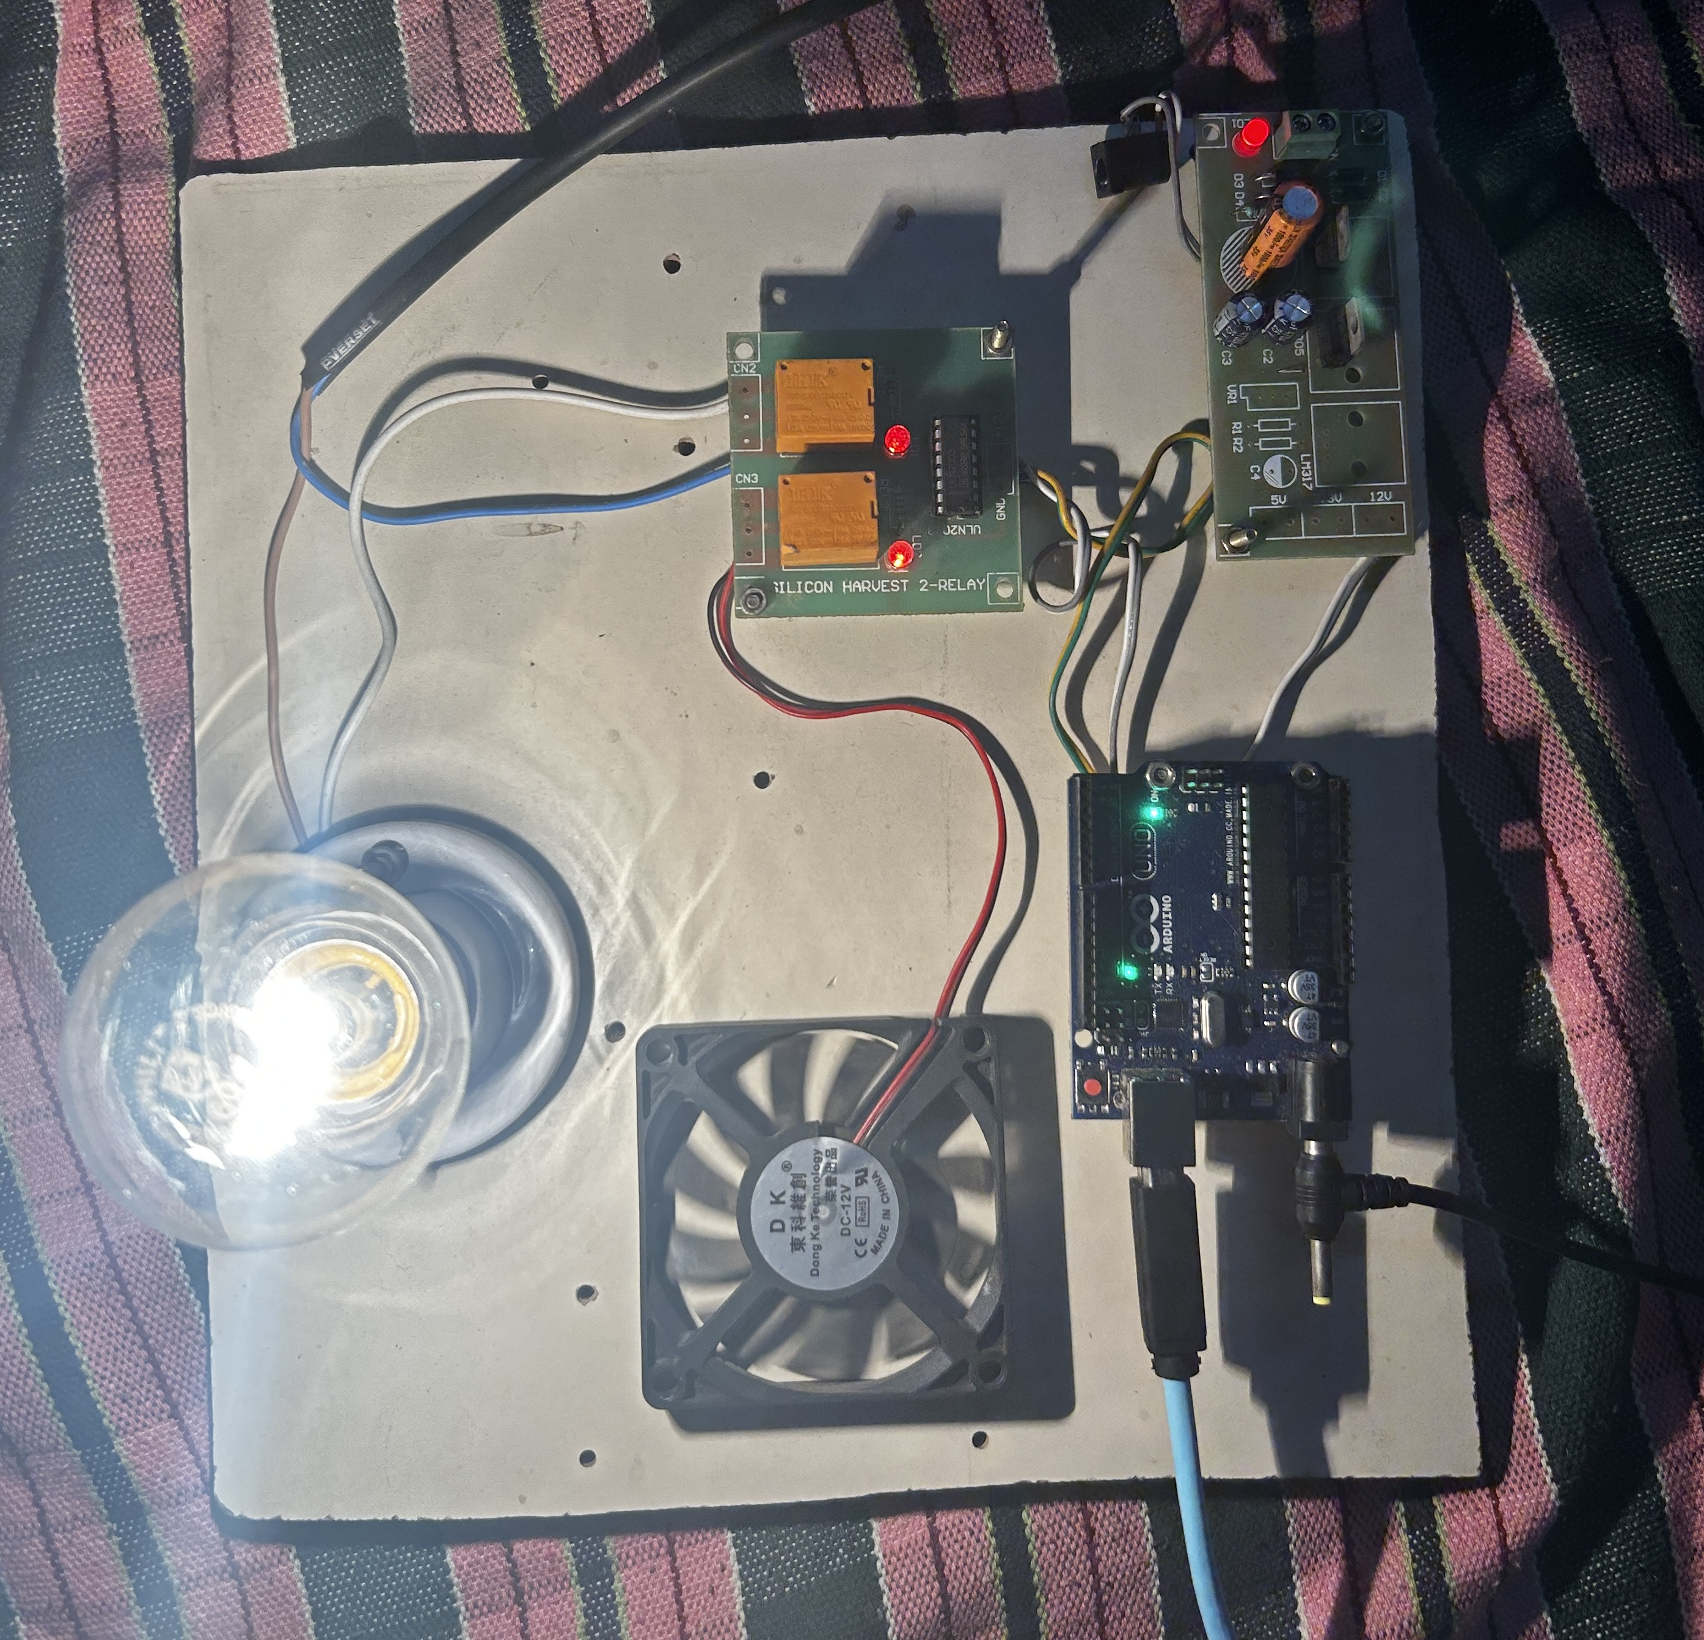

Figure 9. Hardware Setup

**Enclosure and Mounting Hardware:**

* An enclosure may be used to house the hardware components and protect them from dust, moisture, or physical damage.
* Mounting hardware such as brackets or screws may be employed to securely mount the hardware setup in a desired location within the home.

By integrating these hardware components effectively, our system can accurately interpret hand gestures and control household appliances with ease, offering users a seamless and intuitive home automation experience.

**Swing Sign**

Swing gesture, recognized by the gesture sensor, triggers the Arduino Uno to activate the relay module connected to the fan, resulting in the fan turning on at full speed.

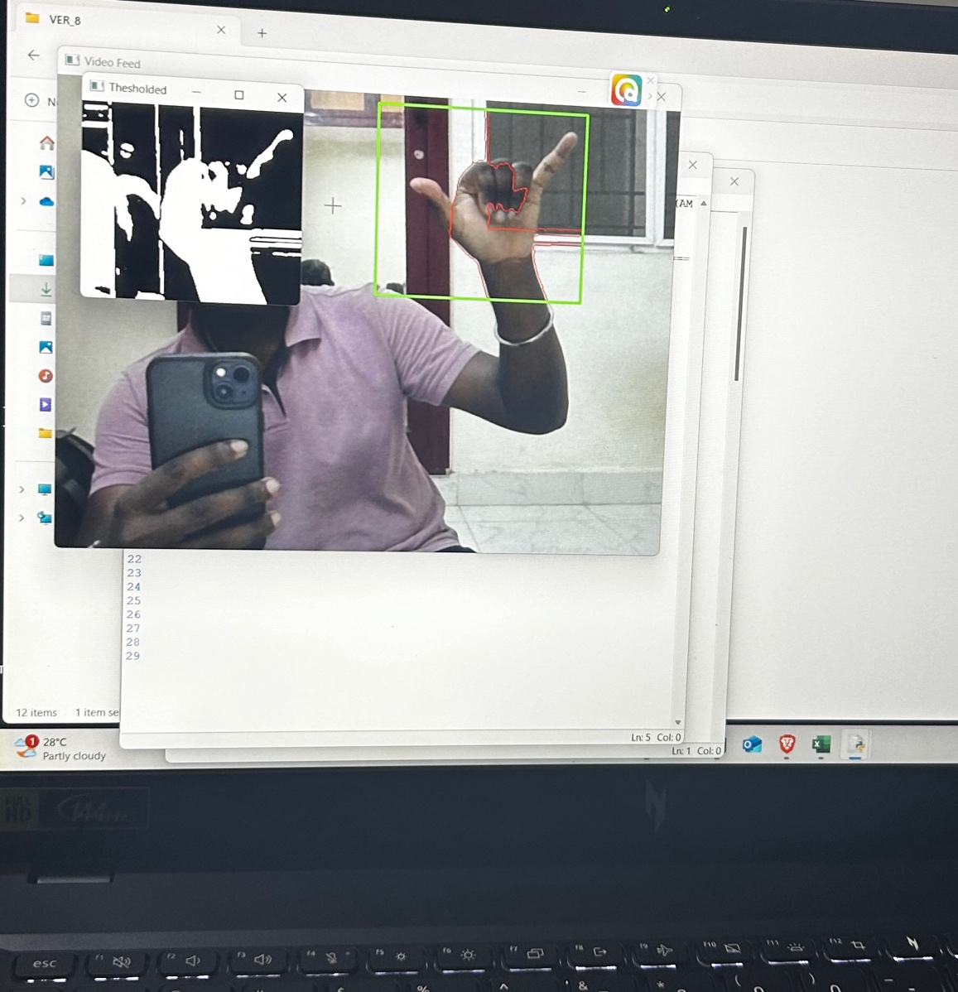

Figure 10. Gesture Recognition for Swing

**Thumbs Up**

The Thumbs up gesture, detected by the gesture sensor, prompts the Arduino Uno to adjust the speed of the fan connected via the relay module, enabling the fan to operate at reduced speed.

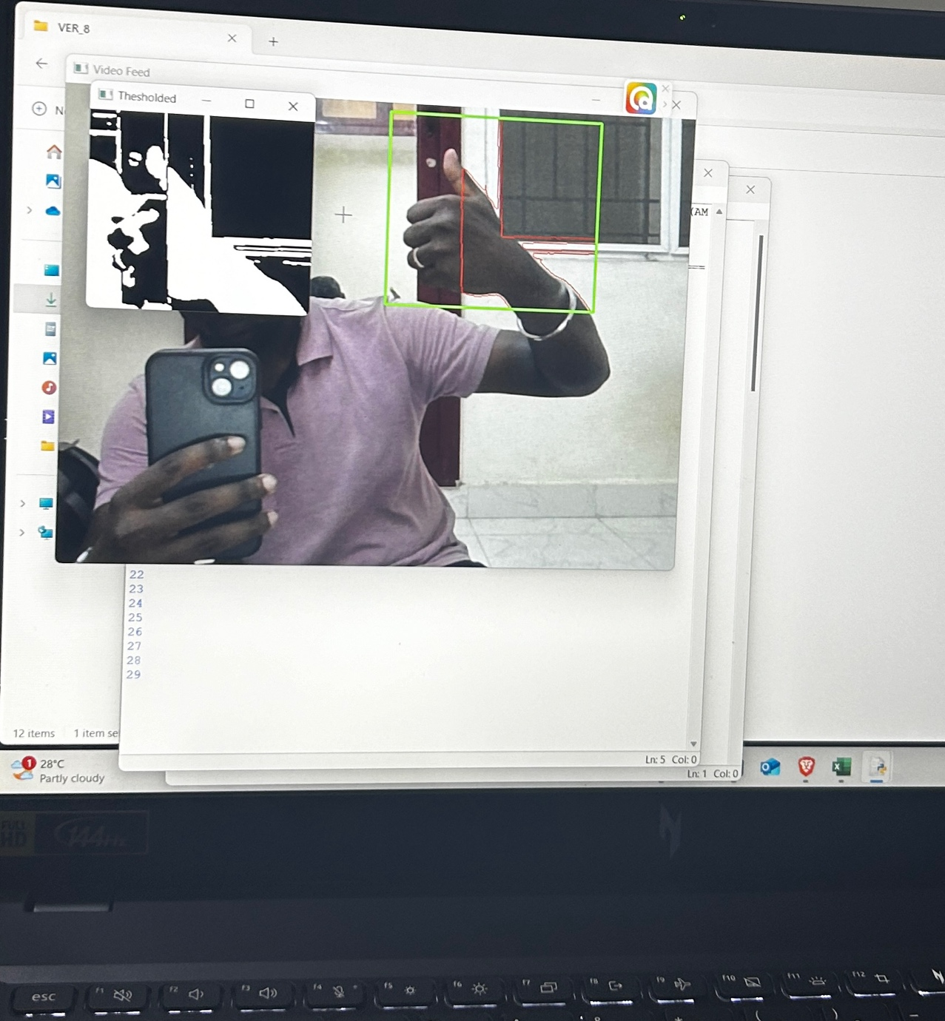

Figure 11. Gesture Recognition for Thumbs up

**Fist**

The Fist gesture, identified by the gesture sensor, instructs the Arduino Uno to activate both the LED light and the bulb simultaneously, utilizing the relay modules connected to each device for control, resulting in increased brightness levels for both lights.

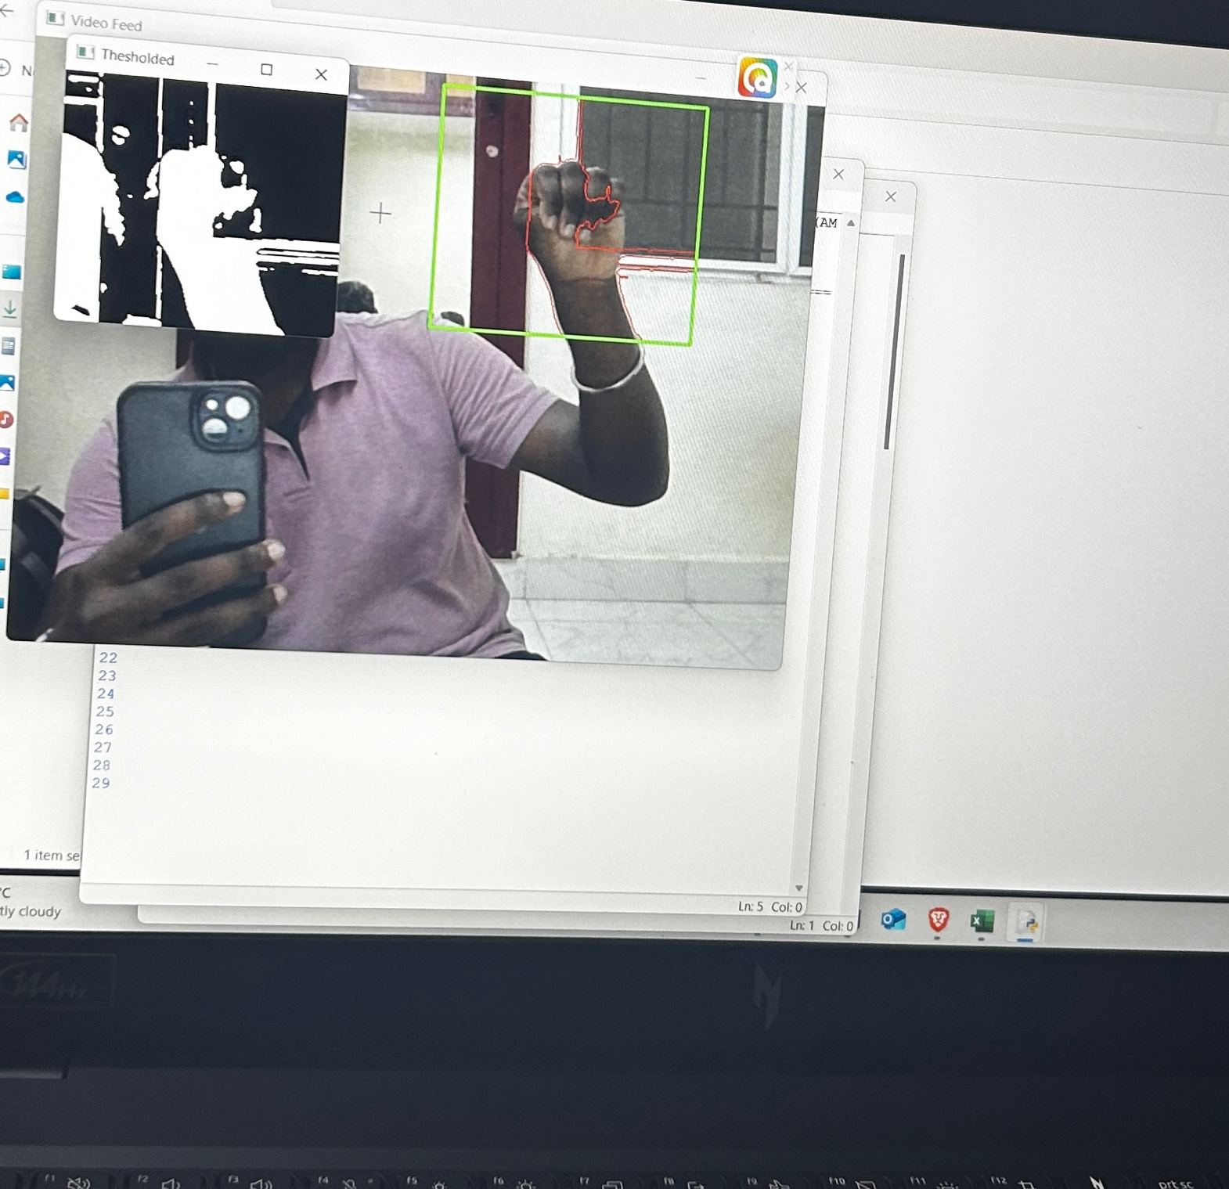

Figure 12. Gesture Recognition for Fist

**Palm**

The Palm gesture, recognized by the gesture sensor, commands the Arduino Uno to decrease the brightness levels of both the LED light and the bulb by adjusting the output of the dimmer module connected to each light source, ensuring a reduction in overall illumination.

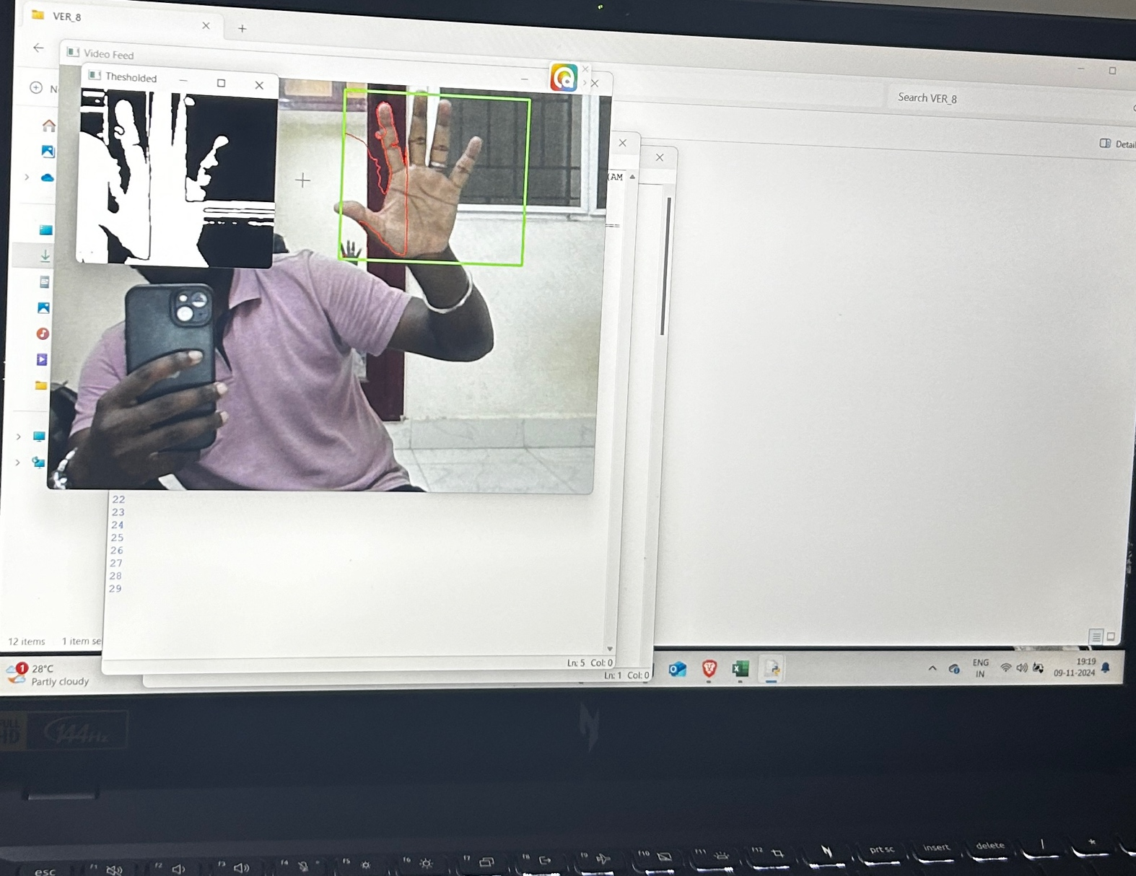

Figure 13. Gesture Recognition for Palm

**Peace Sign**

The Peace gesture, detected by the gesture sensor, triggers the Arduino Uno to turn off the entire home automation system by deactivating all connected devices, including the fan, LED light, and bulb, ensuring complete shutdown and energy conservation.

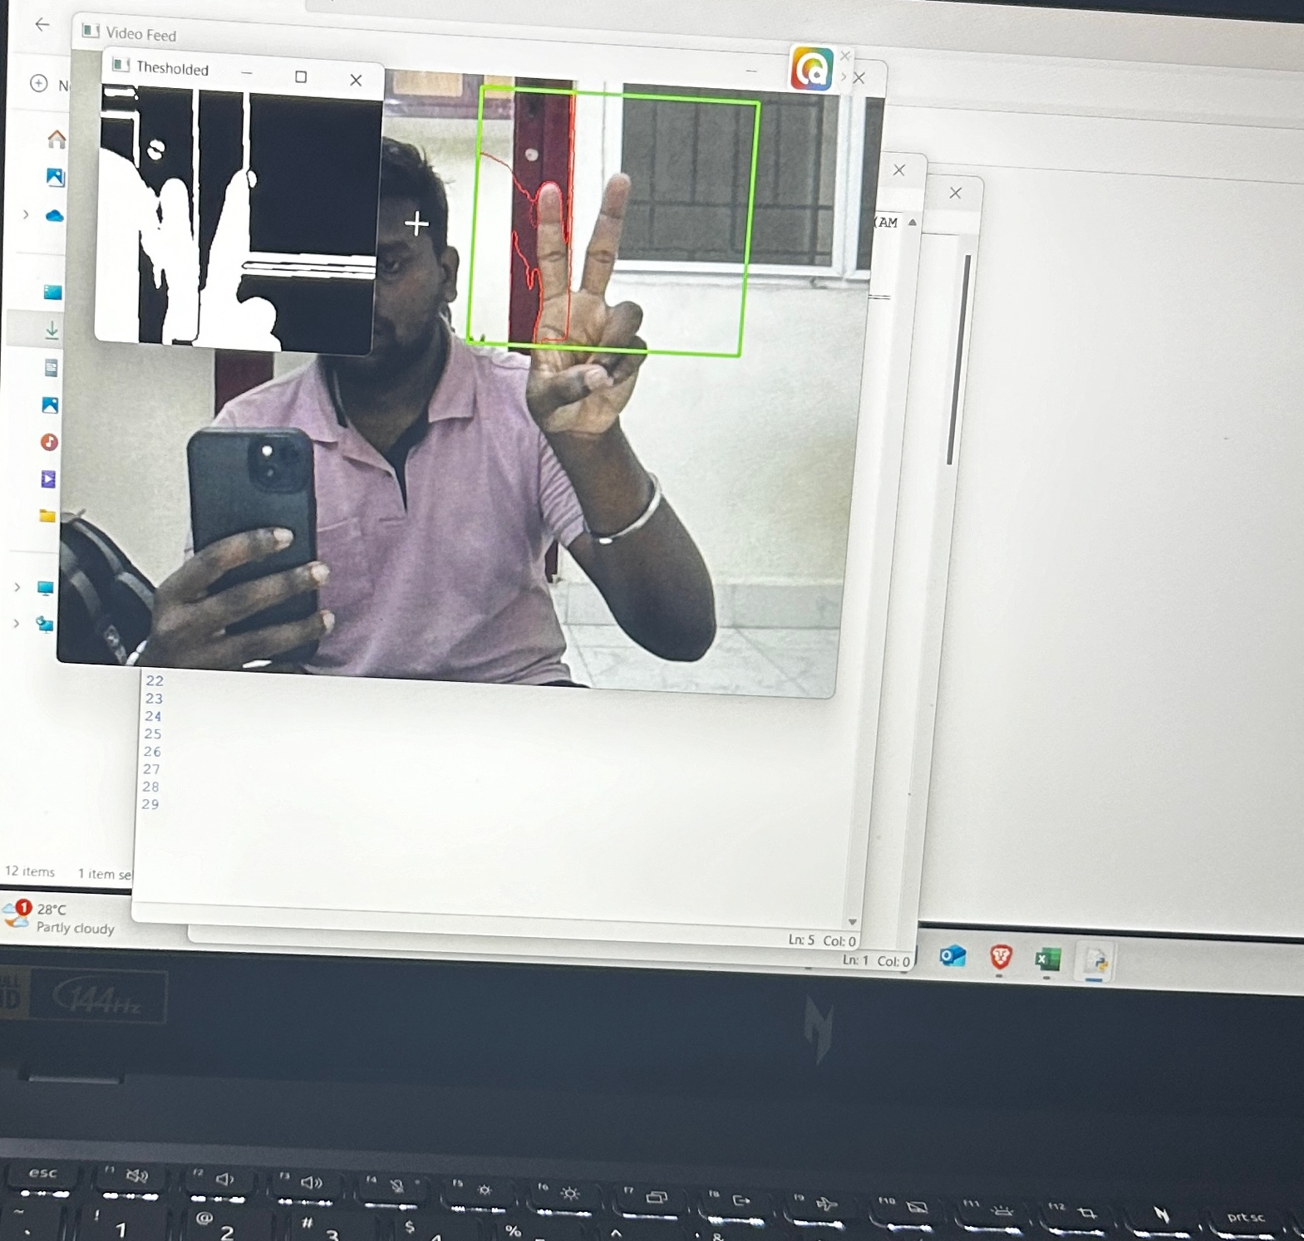

Figure 14. Gesture Recognition for five fingers

**Chapter 4**

**Conclusion and Future Work**

4.1 CONCLUSION

The culmination of our endeavor to develop a home-based automation system using hand gestures marks a significant milestone in the realm of smart home technology. Through meticulous design, implementation, and optimization, we have crafted a solution that offers unparalleled convenience, accessibility, and efficiency to users in controlling their household appliances.

Our system leverages advanced gesture recognition algorithms, sophisticated hardware components, and user-friendly interfaces to create an intuitive and seamless user experience. By harnessing the power of deep learning, we have enabled the system to accurately interpret a wide range of hand gestures in real-time, translating them into actionable commands for controlling lights, fans, and other smart devices.

One of the key strengths of our system lies in its emphasis on accessibility. By incorporating features such as voice commands, tactile feedback, and customizable gesture mappings, we have ensured that individuals with diverse needs, including those with disabilities or mobility impairments, can interact with the system effortlessly.

Furthermore, our system prioritizes efficiency and reliability, with optimization techniques implemented at every level to minimize latency, conserve energy, and enhance overall performance. From hardware acceleration to real-time monitoring, we have left no stone unturned in ensuring that the system operates seamlessly under various environmental conditions.

As we reflect on the journey from concept to implementation, it becomes evident that our home-based automation system has the potential to revolutionize the way people interact with their living spaces. Whether it's turning on the lights with a simple hand gesture or adjusting the fan speed with a flick of the wrist, our system offers users a glimpse into the future of smart home technology.

Our project stands as a testament to innovation, creativity, and the relentless pursuit of excellence. As we look ahead, we remain committed to further refining and enhancing our system, continually pushing the boundaries of what's possible in the realm of home automation. With each advancement, we strive to make everyday living more convenient, accessible, and enjoyable for users around the world.

4.2 FUTURE WORK

While our project represents a significant advancement in the field of home automation using hand gestures, there are several avenues for future exploration and enhancement. Some potential areas for future work include:

* **Fine-Tuning Gesture Recognition:** Continued refinement of the gesture recognition algorithm to improve accuracy and robustness, especially in challenging lighting conditions or with complex hand movements. Exploring alternative deep learning architectures or incorporating additional sensor modalities could further enhance gesture recognition capabilities.
* **Expanded Gesture Vocabulary:** Introducing a broader range of recognized gestures and corresponding actions to offer users more flexibility and control over their smart home devices. This could involve incorporating multi-step gestures or gestures for specific device configurations, allowing for more nuanced interactions.
* **Adaptive Learning:** Implementing adaptive learning techniques to personalize the gesture recognition system based on individual user preferences and habits. By analyzing user interactions over time, the system could adapt its gesture models to better anticipate and respond to user commands.
* **Integration with Smart Assistants:** Integrating the gesture-based home automation system with popular smart assistant platforms such as Amazon Alexa or Google Assistant. This would enable users to control their smart home devices using both voice commands and hand gestures, offering a more comprehensive and intuitive user experience.
* **Enhanced Accessibility Features:** Further enhancing accessibility features to accommodate users with diverse needs, including those with disabilities or mobility impairments. This could involve developing specialized gesture mappings or interface adaptations tailored to specific user requirements.
* **Energy Optimization:** Implementing energy optimization strategies to minimize power consumption and extend the battery life of wireless gesture sensors or smart home devices. This could include intelligent sleep modes, dynamic power management, or energy-efficient hardware designs.
* **Multi-Modal Interaction:** Exploring the integration of multi-modal interaction techniques, such as combining hand gestures with voice commands or touch-based interactions. This would offer users multiple ways to interact with their smart home devices, enhancing flexibility and convenience.
* **Scalability and Interoperability:** Designing the system architecture to be scalable and interoperable with a wide range of smart home devices and protocols. This would enable seamless integration with existing smart home ecosystems and facilitate the adoption of gesture-based control across various devices and platforms.
* **User Experience Studies:** Conducting user experience studies and usability testing to gather feedback from users and identify areas for improvement. Iterative refinement based on user feedback would ensure that the system meets the needs and preferences of its intended users.

By addressing these areas of future work, our gesture-based home automation system can continue to evolve and innovate, offering users an intuitive, accessible, and efficient way to interact with their smart home environments.

### REFERENCES

4.3 REFERENCES

[1] Neha G , Harika CH , Swetha G , Vishnu Kanth G, “Finger gesture recognition based home automation using IOT,” May 2023.

[2] R Jayanthi, A Bhuvaneswari, S Rajkumar, K P Rama Prabha, “Vision based hand gesture pattern recognition enabled home automation system using Internet of Things,” August 2021.

[3] P. Anuradha , K. Vasanth , G. Renuka , A.Rajeshwar Rao, “IoT based enabling home automation system for individuals with diverse disabilities,” 2023.

[4] J L SARWANI Theeparthi,Sape Chittibabulu, “IOT based home applications controling using vision and gesture through raspberry pi,” 2023.

[5] A. D. Harale , Amruta S. Bankar and K. J. Karande, “Gestures Controlled Home Automation using Deep Learning: A Review,” 2021.

[6] F. Sabbarese , L. Magliulo, P. Carratu , M. Romano, “Hand gesture recognition using recurrent neural networks and synthetic data generation,” 2023.

[7] Enmin Zhong , Carlos R. del-Blanco , Daniel Berjón , Fernando Jaureguizar and Narciso García, “Real-Time Monocular Skeleton-Based Hand Gesture Recognition Using 3D-Jointsformer,” 2023.

[8] Sangamesh Narayanpethkar, Abhishek Makude, Samrudh S, Yashraj Khose, A. D. Gujar, “Computer Vision based Media Control using Hand Gestures,” 2023.

[9] Aseel Ghazi Mahmoud, Ahmed Mudheher Hasan, Nadia Moqble Hassan, “Convolutional neural networks framework for human hand gesture recognition,” 2023.

[10] Gibran Benitez-Garcia , Lidia Prudente-Tixteco , Luis Carlos Castro-Madrid , Rocio Toscano-Medina, “Improving Real-Time Hand Gesture Recognition with Semantic Segmentation,” 2021.

[11] Dr.China Venkateswarlu Sonagiri Dr Puralasetty Ashok Babu , Vijay Vallabhuni , Sivanagaraju Veerastu, “Artificial Intelligence Based Smart Home Automation System Using Internet of Things,” 2021.

[12] Vaidish Srivastava , Srajan Shukla, Radhey Shyam, “Utilizing ML for Hand Gesture Recognition,” 20223.

### APPENDICES

4.4 APPENDICES

Appendix 1:

**Python Code :**

from tensorflow.python.framework import ops

ops.reset_default_graph()

import tensorflow as tf

import serial

import time

import tflearn

from tflearn.layers.conv import conv_2d,max_pool_2d

from tflearn.layers.core import input_data,dropout,fully_connected

from tflearn.layers.estimator import regression

import numpy as np

from PIL import Image

import cv2

import imutils

# global variables

bg = None

ser = serial.Serial('COM3', 9600, timeout=1)

def resizeImage(imageName):

basewidth = 100

img = Image.open(imageName)

wpercent = (basewidth/float(img.size[0]))

hsize = int((float(img.size[1])*float(wpercent)))

img = img.resize((basewidth,hsize), Image.ANTIALIAS)

img.save(imageName)

def run_avg(image, aWeight):

global bg

# initialize the background

if bg is None:

bg = image.copy().astype("float")

return

# compute weighted average, accumulate it and update the background

cv2.accumulateWeighted(image, bg, aWeight)

def segment(image, threshold=25):

global bg

# find the absolute difference between background and current frame

diff = cv2.absdiff(bg.astype("uint8"), image)

# threshold the diff image so that we get the foreground

thresholded = cv2.threshold(diff,

threshold,

255,

cv2.THRESH_BINARY)[1]

# get the contours in the thresholded image

(cnts, _) = cv2.findContours(thresholded.copy(),

cv2.RETR_EXTERNAL,

cv2.CHAIN_APPROX_SIMPLE)

# return None, if no contours detected

if len(cnts) == 0:

return

else:

# based on contour area, get the maximum contour which is the hand

segmented = max(cnts, key=cv2.contourArea)

return (thresholded, segmented)

def main():

# initialize weight for running average

aWeight = 0.5

# get the reference to the webcam

#camera = cv2.VideoCapture(0)

camera = cv2.VideoCapture(0, cv2.CAP_DSHOW)

# region of interest (ROI) coordinates

top, right, bottom, left = 10, 350, 225, 590

# initialize num of frames

num_frames = 0

start_recording = False

# keep looping, until interrupted

while(True):

# get the current frame

(grabbed, frame) = camera.read()

# resize the frame

frame = imutils.resize(frame, width = 700)

# flip the frame so that it is not the mirror view

frame = cv2.flip(frame, 1)

# clone the frame

clone = frame.copy()

# get the height and width of the frame

(height, width) = frame.shape[:2]

# get the ROI

roi = frame[top:bottom, right:left]

# convert the roi to grayscale and blur it

gray = cv2.cvtColor(roi, cv2.COLOR_BGR2GRAY)

gray = cv2.GaussianBlur(gray, (7, 7), 0)

# to get the background, keep looking till a threshold is reached

# so that our running average model gets calibrated

if num_frames < 30:

run_avg(gray, aWeight)

else:

# segment the hand region

hand = segment(gray)

# check whether hand region is segmented

if hand is not None:

# if yes, unpack the thresholded image and

# segmented region

(thresholded, segmented) = hand

# draw the segmented region and display the frame

cv2.drawContours(clone, [segmented + (right, top)], -1, (0, 0, 255))

if start_recording:

cv2.imwrite('Temp.png', thresholded)

resizeImage('Temp.png')

predictedClass, confidence = getPredictedClass()

showStatistics(predictedClass, confidence)

print(predictedClass)

cv2.imshow("Thesholded", thresholded)

# draw the segmented hand

cv2.rectangle(clone, (left, top), (right, bottom), (0,255,0), 2)

# increment the number of frames

num_frames += 1

# display the frame with segmented hand

cv2.imshow("Video Feed", clone)

# observe the keypress by the user

keypress = cv2.waitKey(1) & 0xFF

# if the user pressed "q", then stop looping

if keypress == ord("q"):

break

if keypress == ord("s"):

start_recording = True

def getPredictedClass():

# Predict

image = cv2.imread('Temp.png')

gray_image = cv2.cvtColor(image, cv2.COLOR_BGR2GRAY)

prediction = model.predict([gray_image.reshape(89, 100, 1)])

return np.argmax(prediction), (np.amax(prediction) / (prediction[0][0] + prediction[0][1] + prediction[0][2]))

def showStatistics(predictedClass, confidence):

textImage = np.zeros((300,512,3), np.uint8)

className = ""

if predictedClass == 0:

className = "Swing"

ser.write(b"A\n") # Send "Swing" over serial

print("serial A send")

elif predictedClass == 1:

className = "Palm"

ser.write(b"B\n") # Send "Palm" over serial

print("serial B send")

elif predictedClass == 2:

className = "Fist"

ser.write(b"C\n") # Send "Fist" over serial

print("serial C send")

elif predictedClass == 3:

className = "dina"

ser.write(b"D\n") # Send "Fist" over serial

print("serial D send")

cv2.putText(textImage,"Pedicted Class : " + className,

(30, 30),

cv2.FONT_HERSHEY_SIMPLEX,

1,

(255, 255, 255),

2)

cv2.putText(textImage,"Confidence : " + str(confidence * 100) + '%',

(30, 100),

cv2.FONT_HERSHEY_SIMPLEX,

1,

(255, 255, 255),

2)

cv2.imshow("Statistics", textImage)

# Model defined

#tf.reset_default_graph()

convnet=input_data(shape=[None,89,100,1],name='input')

convnet=conv_2d(convnet,32,2,activation='relu')

convnet=max_pool_2d(convnet,2)

convnet=conv_2d(convnet,64,2,activation='relu')

convnet=max_pool_2d(convnet,2)

convnet=conv_2d(convnet,128,2,activation='relu')

convnet=max_pool_2d(convnet,2)

convnet=conv_2d(convnet,256,2,activation='relu')

convnet=max_pool_2d(convnet,2)

convnet=conv_2d(convnet,256,2,activation='relu')

convnet=max_pool_2d(convnet,2)

convnet=conv_2d(convnet,128,2,activation='relu')

convnet=max_pool_2d(convnet,2)

convnet=conv_2d(convnet,64,2,activation='relu')

convnet=max_pool_2d(convnet,2)

convnet=fully_connected(convnet,1000,activation='relu')

convnet=dropout(convnet,0.75)

convnet=fully_connected(convnet,3,activation='softmax')

convnet=regression(convnet,optimizer='adam',learning_rate=0.001,loss='categorical_crossentropy',name='regression')

model=tflearn.DNN(convnet,tensorboard_verbose=0)

# Load Saved Model

model.load("TrainedModel/GestureRecogModel.tfl")

main()

**Arduino Code :**

#include <LiquidCrystal.h>

#include<SoftwareSerial.h>

#define relay1 8

#define relay2 9

#define relay3 10

#define relay4 11

char buff;

SoftwareSerial BT(3,2); // RX, TX

void setup() {

// put your setup code here, to run once:

Serial.begin(9600);

BT.begin(9600);

pinMode(relay1,OUTPUT);

pinMode(relay2,OUTPUT);

pinMode(relay3,OUTPUT);

pinMode(relay4,OUTPUT);

digitalWrite(relay1,LOW);

digitalWrite(relay2,LOW);

digitalWrite(relay3,LOW);

digitalWrite(relay4,LOW);

}

void loop() {

if (Serial.available())

{

buff = Serial.read();

//lcd.setCursor(0,1);

if(buff=='A')

{

digitalWrite(relay1,HIGH);

//Serial.println("A Received");

//lcd.print("Relay 1 ON ");

}

else if (buff=='B')

{

digitalWrite(relay1,LOW);

//Serial.println("B Received");

// lcd.print("Relay 1 OFF ");

}

else if (buff=='C')

{

digitalWrite(relay2,HIGH);

// Serial.println("C Received");

// lcd.print("Relay 2 ON ");

}

else if (buff=='D')

{

digitalWrite(relay2,LOW);

// Serial.println("D Received");

// lcd.print("Relay 2 OFF ");

}

/* else if (buff=='E')

{

digitalWrite(relay3,HIGH);

lcd.print("Relay 3 ON ");

}

else if (buff=='F')

{

digitalWrite(relay3,LOW);

lcd.print("Relay 3 OFF ");

}

else if (buff=='G')

{

digitalWrite(relay4,HIGH);

lcd.print("Relay 4 ON ");

}

else if (buff=='H')

{

digitalWrite(relay4,LOW);

lcd.print("Relay 4 OFF ");

}

else if (buff=='I')

{

digitalWrite(relay1,HIGH);

lcd.print("Relay 5 ON ");

}

else if (buff=='J')

{

digitalWrite(relay1,LOW);

lcd.print("Relay 5 OFF ");

}

else if (buff=='K')

{

digitalWrite(relay6,HIGH);

lcd.print("Relay 6 ON ");

}

else if (buff=='L')

{

digitalWrite(relay6,LOW);

lcd.print("Relay 6 OFF ");

} */

}

delay(1000);

}